MACHINE LEARNING - [18DCS007]

**PRACTICAL 1**



TASK DESCRIPTION:

Perform the following using Python Pandas and Matplotlib library on given dataset:

i) Deal with missing values in the data either by deleting records or using mean/median/mode imputation.

ii) Detect if Outliers exist and Plot the data distribution using Box Plots, Scatter Plots and Histograms of matplotlib library

iii) Create and display the correlation matrix of all features of the data. Record and Analyze Observations

# Data Used for Problem

## Dataset Description:

Dataset is downloaded from https://drive.google.com/file/d/1HnpfG2xj_6EZ7Tgle2QB9Yn_YS7r7uV

Dataset name is New Car Dataset (Custom, Scrapped & Private)

Dataset has 32317 number of attributes and 234 number of samples.

Dataset has 2 types of samples. (Numerical And Categorical)

Does dataset have a target attribute? [YES]

## Did it have missing values and how did you deal with them?

Yes dataset consist of missing values, used a dropna function to deal with it.

## Did you perform any data transformation tasks?

Replaced missing - values with NaN value.

## Did you perform any other data wrangling tasks?

Yes, I changed dtype of columns from object to float for boxplot function.

# Machine Learning Model

## What algorithm/ model did you use and with which parameters?

As this practical is just for basics of some python libraries, no ML algorithm was implemented.

## What are other algorithms/ models you could have used alternatively?

NaN

## What percentage of the dataset did you use for training and testing and how long did you train for in terms of iterations/convergence/epochs?

No data splitting.

# Evaluation

## Which evaluation metric(s) did you use for the task?

NaN

## Did your model underfit or overfit or did it perfectly fit the test data?

NaN

## Did you train and evaluate the model again after changing its parameters? Why?

NaN

## What was the final accuracy/evaluation metric score that you obtained?

NaN

PRACTICAL LEARNING OUTCOME:

Learned basic of python PANDAS libraries and implemented it on dataset.

CODE & OUTPUT:

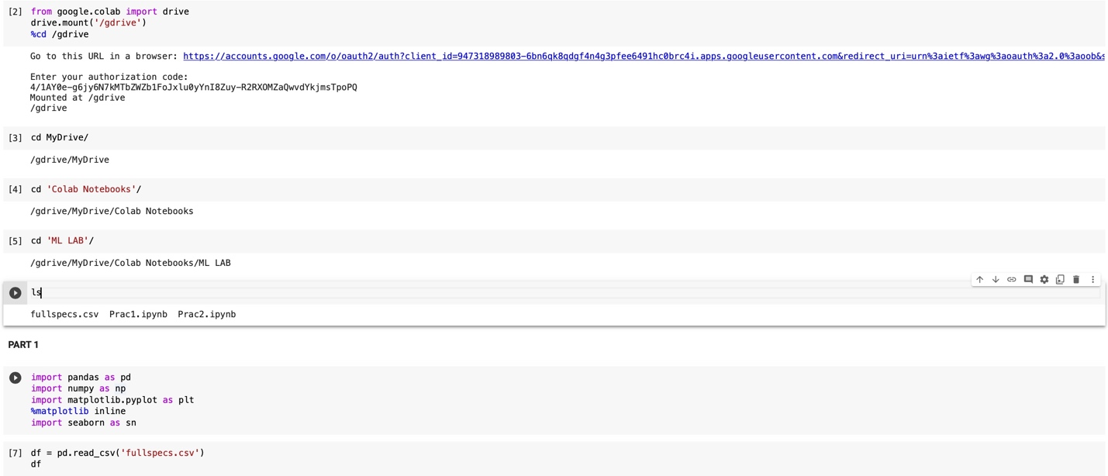 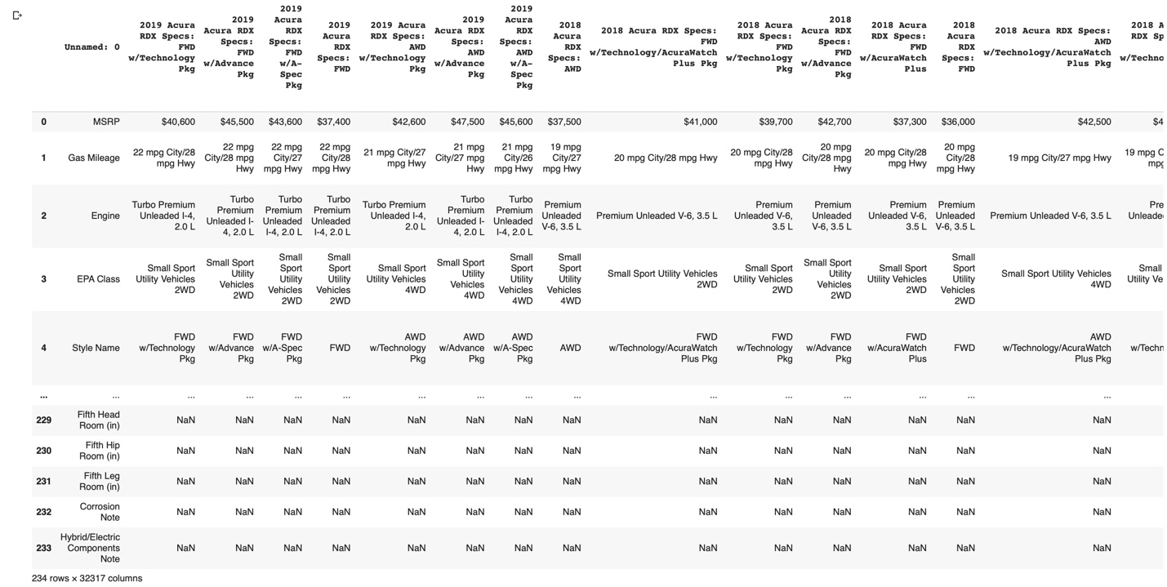

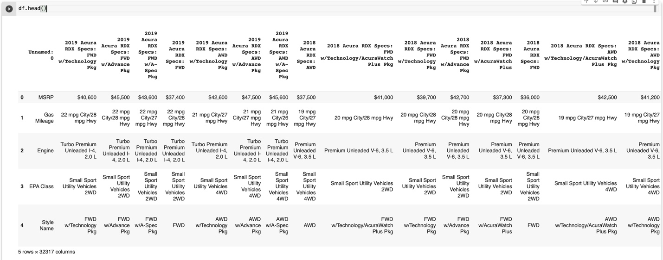 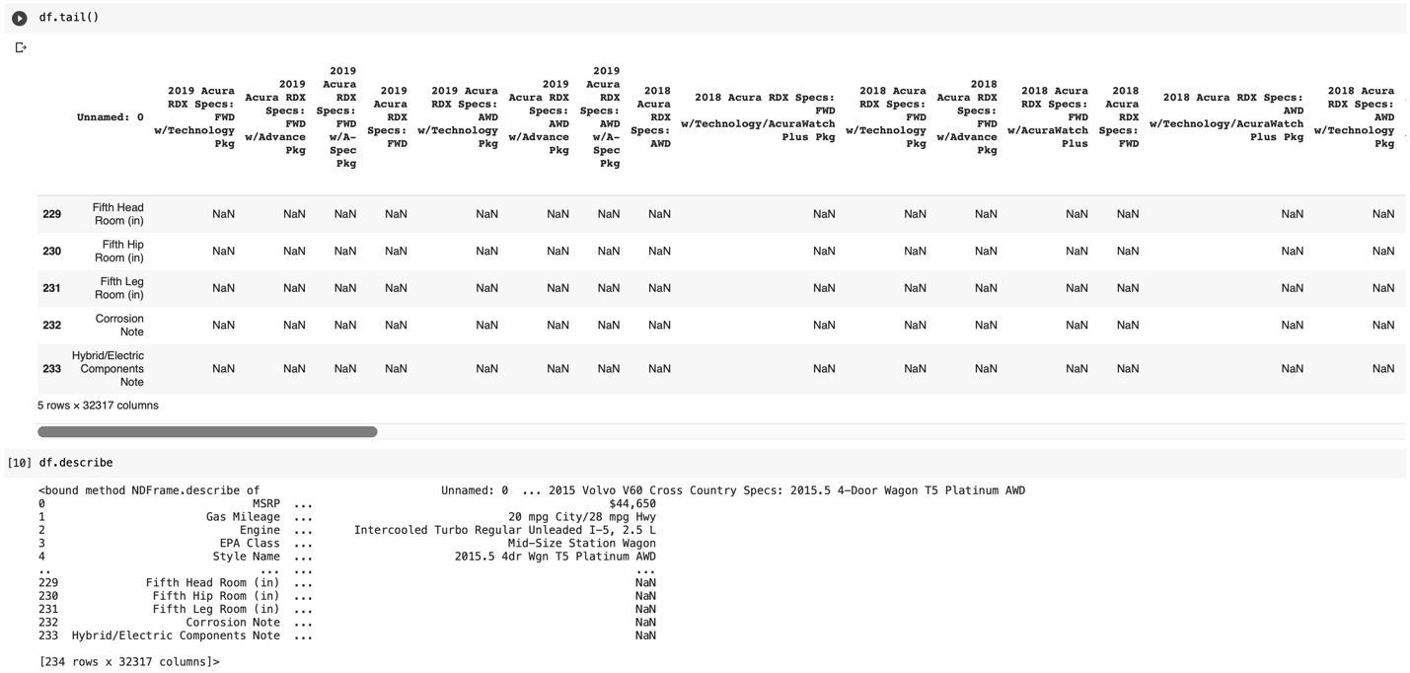

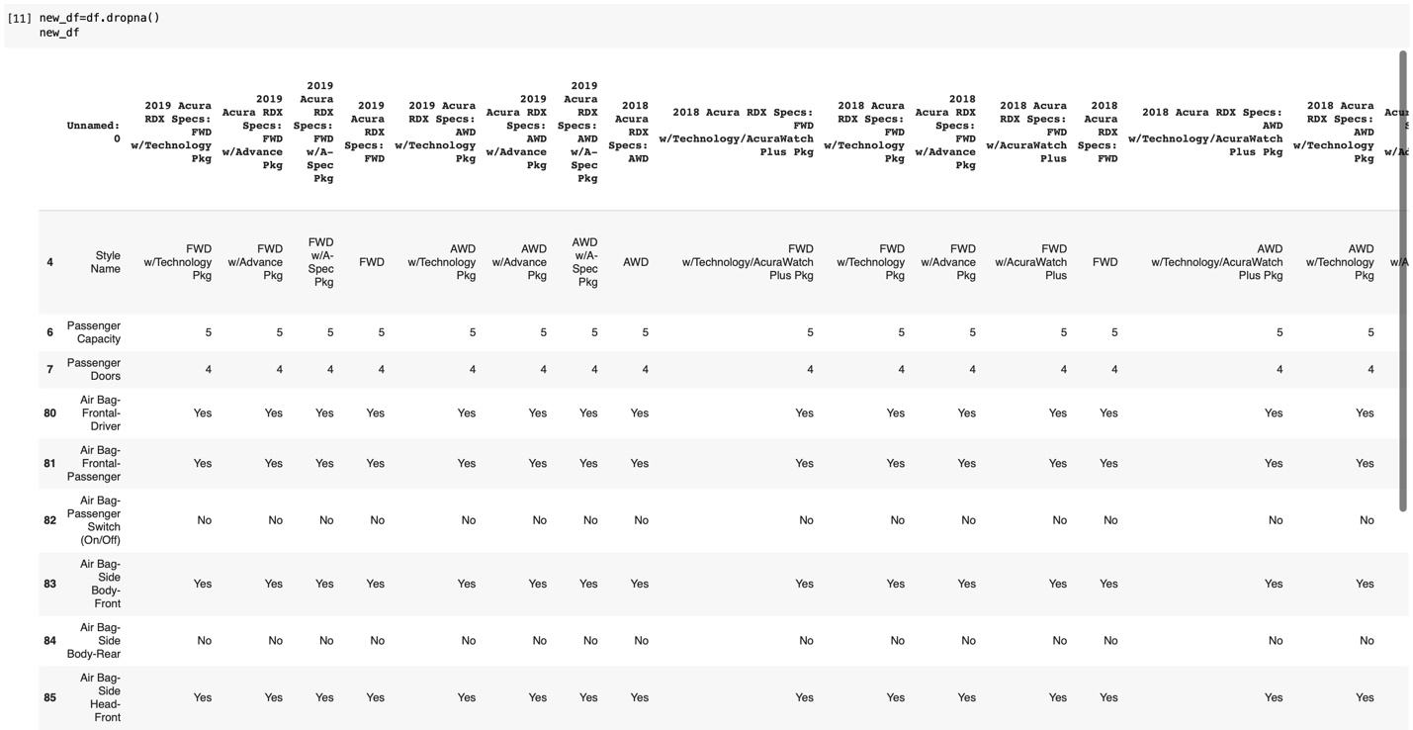 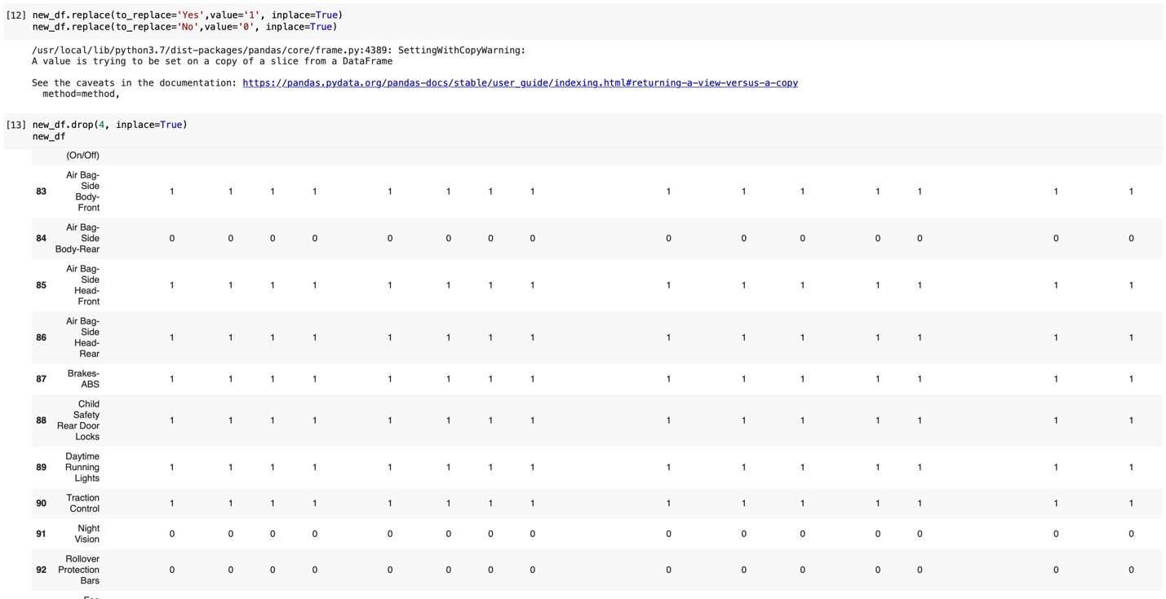

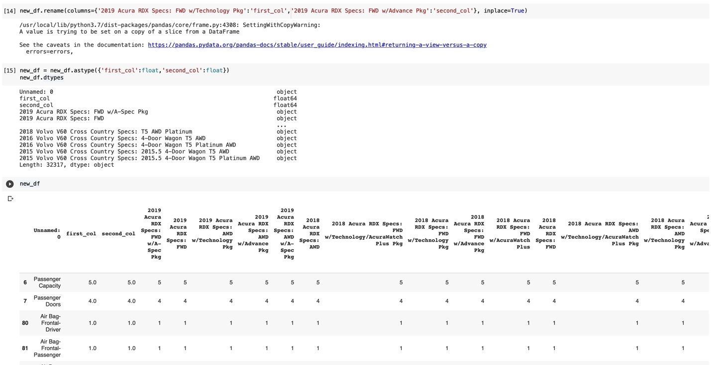

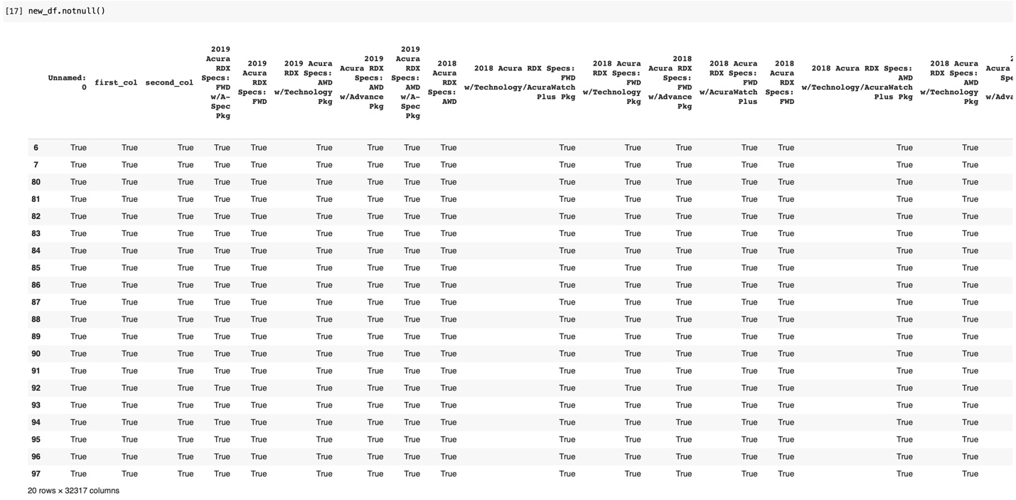 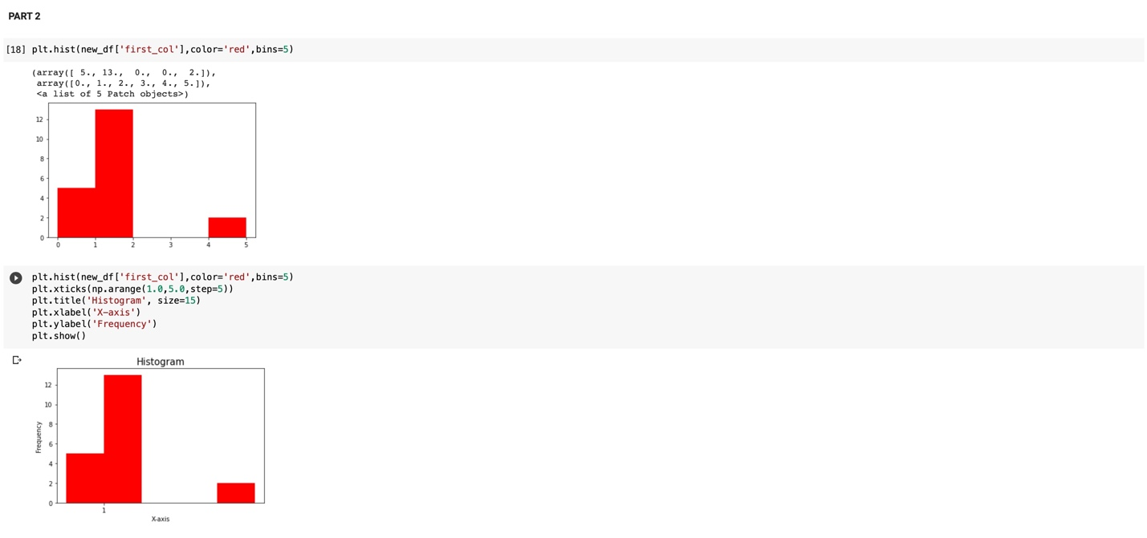

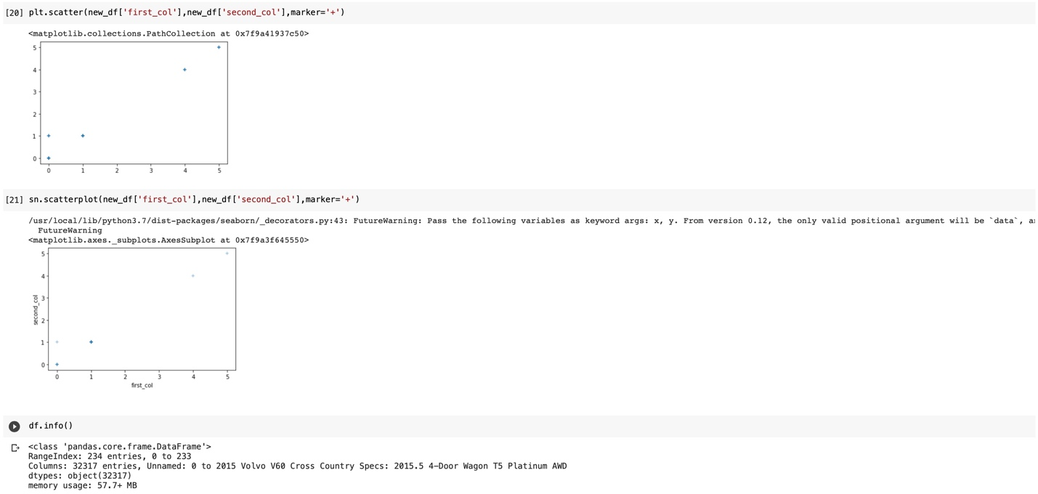

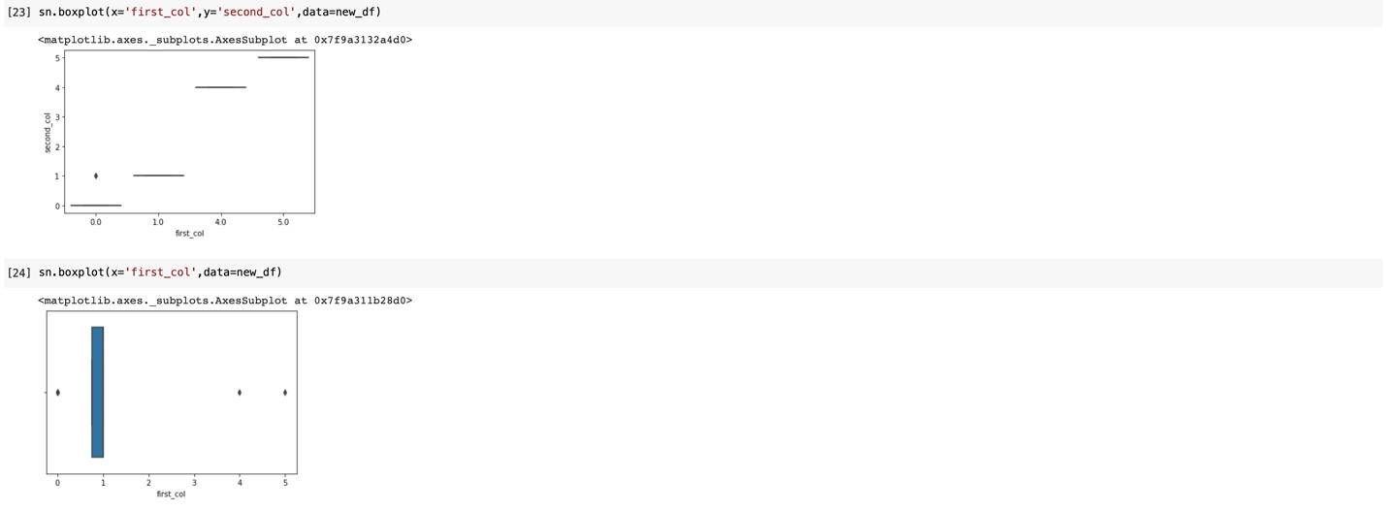 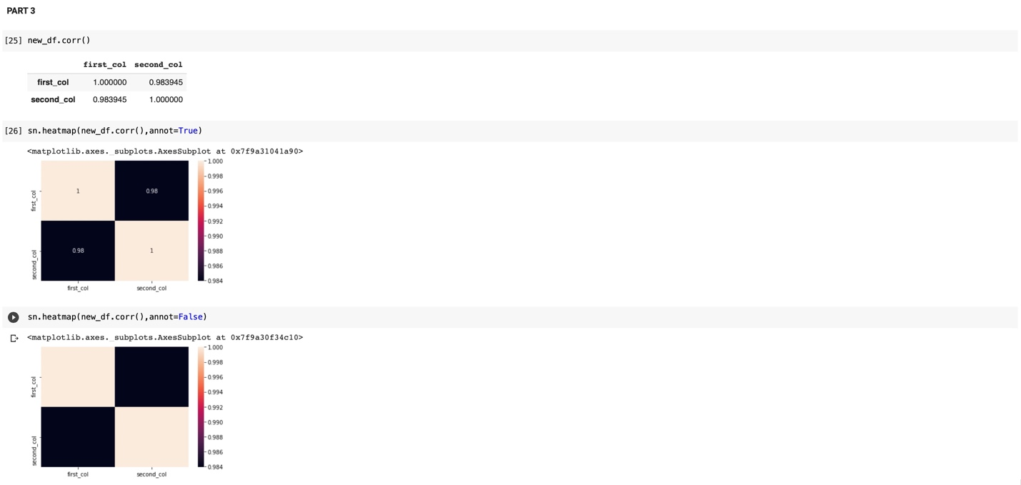

**PRACTICAL 2**



TASK DESCRIPTION:

For given Dataset (you may continue to use the same processed dataset from experiment 1 only for this experiment) , perform the following using Python Pandas and scikit-learn library or by writing your own user-defined function:

i) Perform Data Standardization and Normalization.  
ii) Select the 10 best features of the data using different statistical scoring methods. (Hint: Chi-Squared Statistical Test is a good scoring method)

iii) Split the data into training and testing sets in a ratio of 80:20.

# Data Used for Problem

## Dataset Description:

Dataset is downloaded from https://drive.google.com/file/d/1HnpfG2xj_6EZ7Tgle2QB9Yn_YS7r7uV

Dataset name is New Car Dataset (Custom, Scrapped & Private)

Dataset has 32317 number of attributes and 234 number of samples.

Dataset has 2 types of samples. (Numerical And Categorical)

Does dataset have a target attribute? [YES]

## Did it have missing values and how did you deal with them?

Yes dataset consist of missing values, used a dropna function to deal with it.

## Did you perform any data transformation tasks?

Replaced missing - values with NaN value.

## Did you perform any other data wrangling tasks?

Yes, I changed dtype of columns from object to float for boxplot function.

# Machine Learning Model

## What algorithm/ model did you use and with which parameters?

As this practical is just for basics of some python libraries, no ML algorithm was implemented.

## What are other algorithms/ models you could have used alternatively?

NaN

## What percentage of the dataset did you use for training and testing and how long did you train for in terms of iterations/convergence/epochs?

No data splitting.

# Evaluation

## Which evaluation metric(s) did you use for the task?

NaN

## Did your model underfit or overfit or did it perfectly fit the test data?

NaN

## Did you train and evaluate the model again after changing its parameters? Why?

NaN

## What was the final accuracy/evaluation metric score that you obtained?

NaN

PRACTICAL LEARNING OUTCOME:

Learned about some important python libraries and also implemented how to split data in train and test dataset, other than this we learn how to standard and normalize dataset. And how to feature data with statistical scoring methods.

CODE & OUTPUT: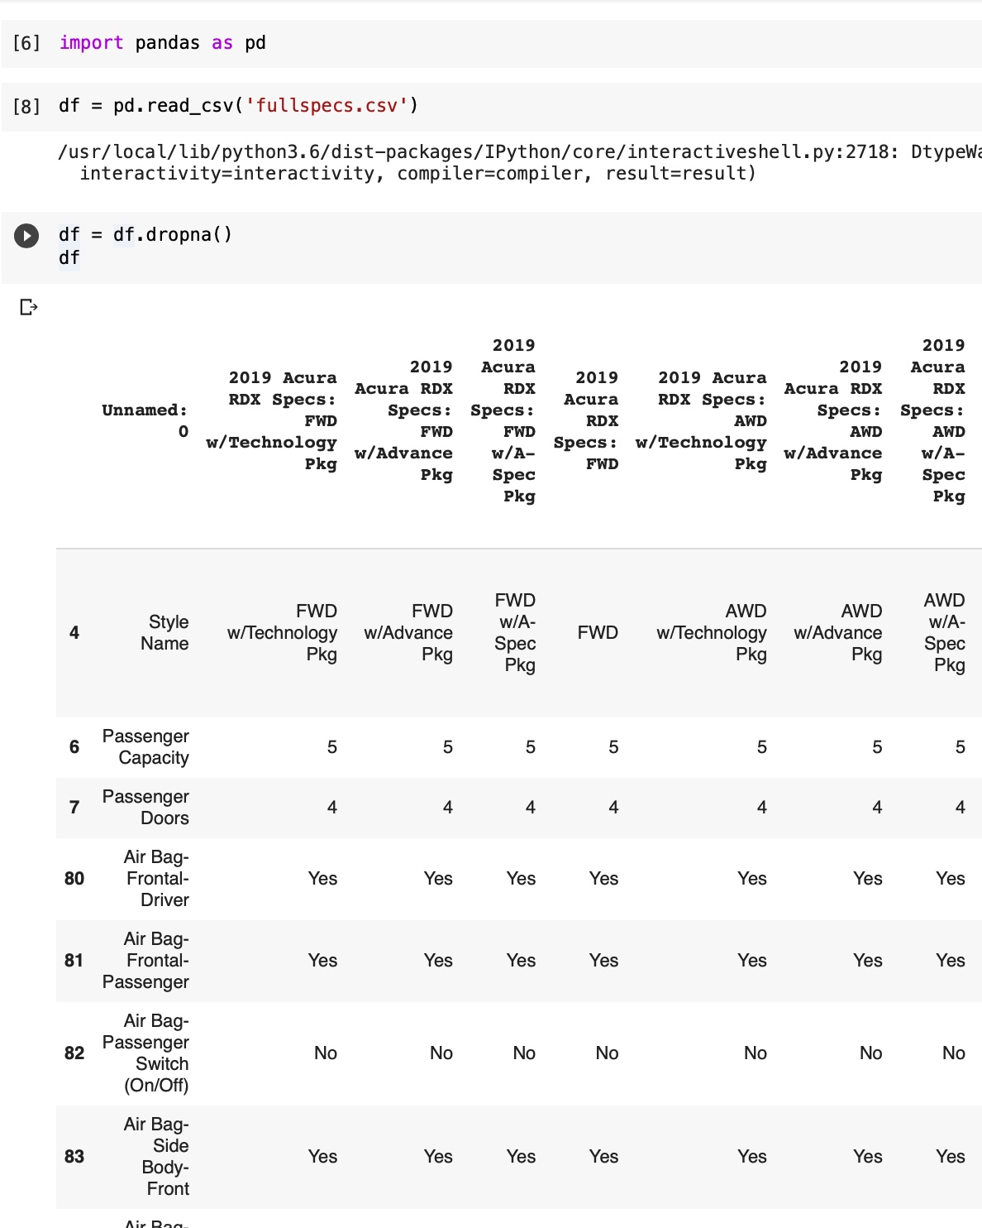

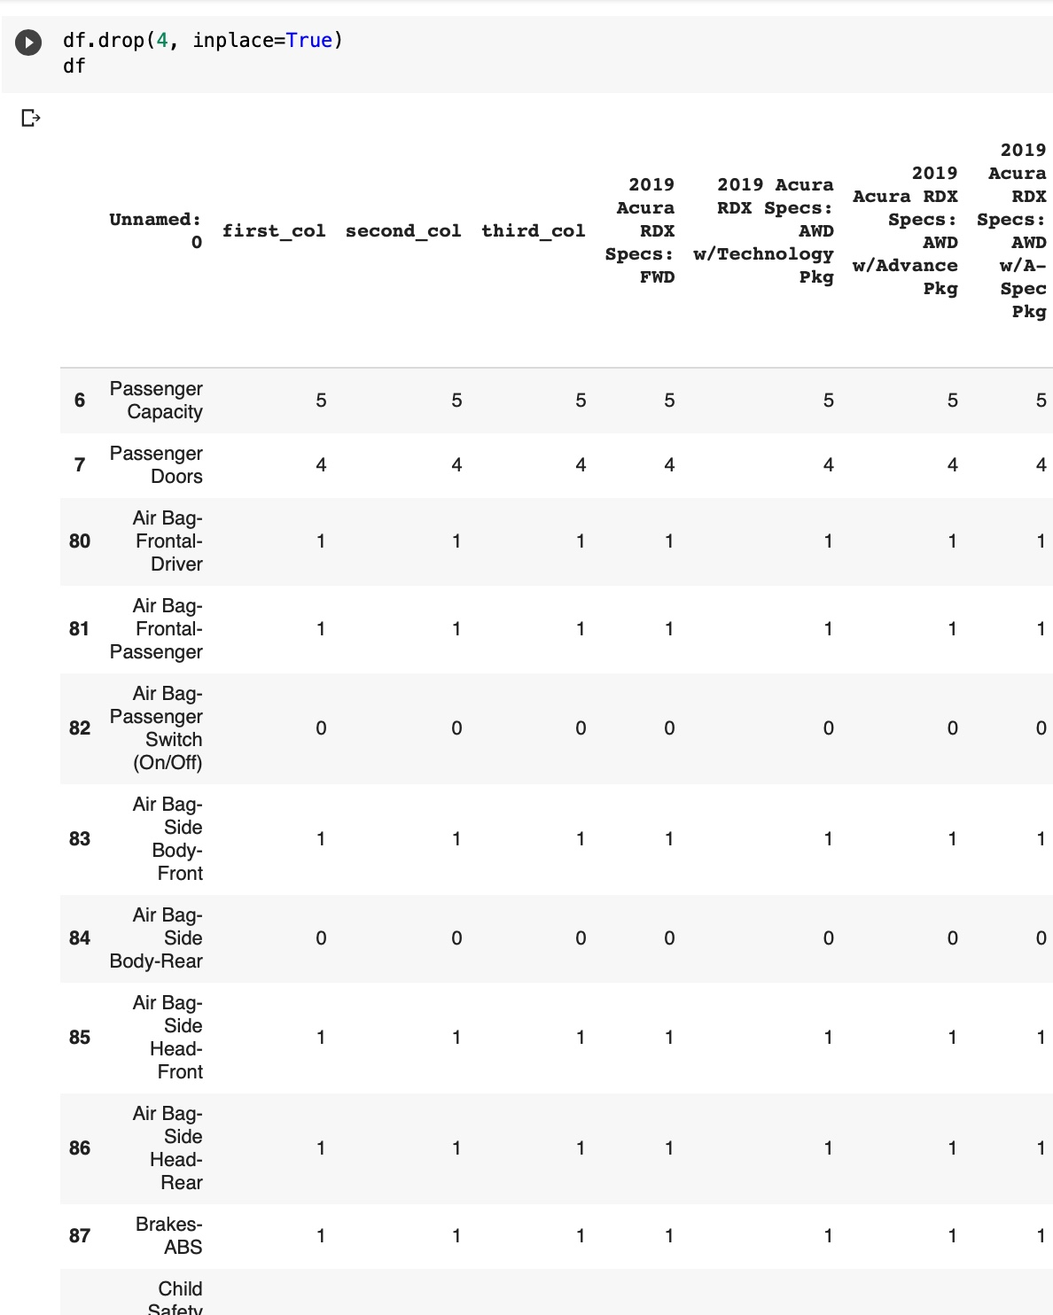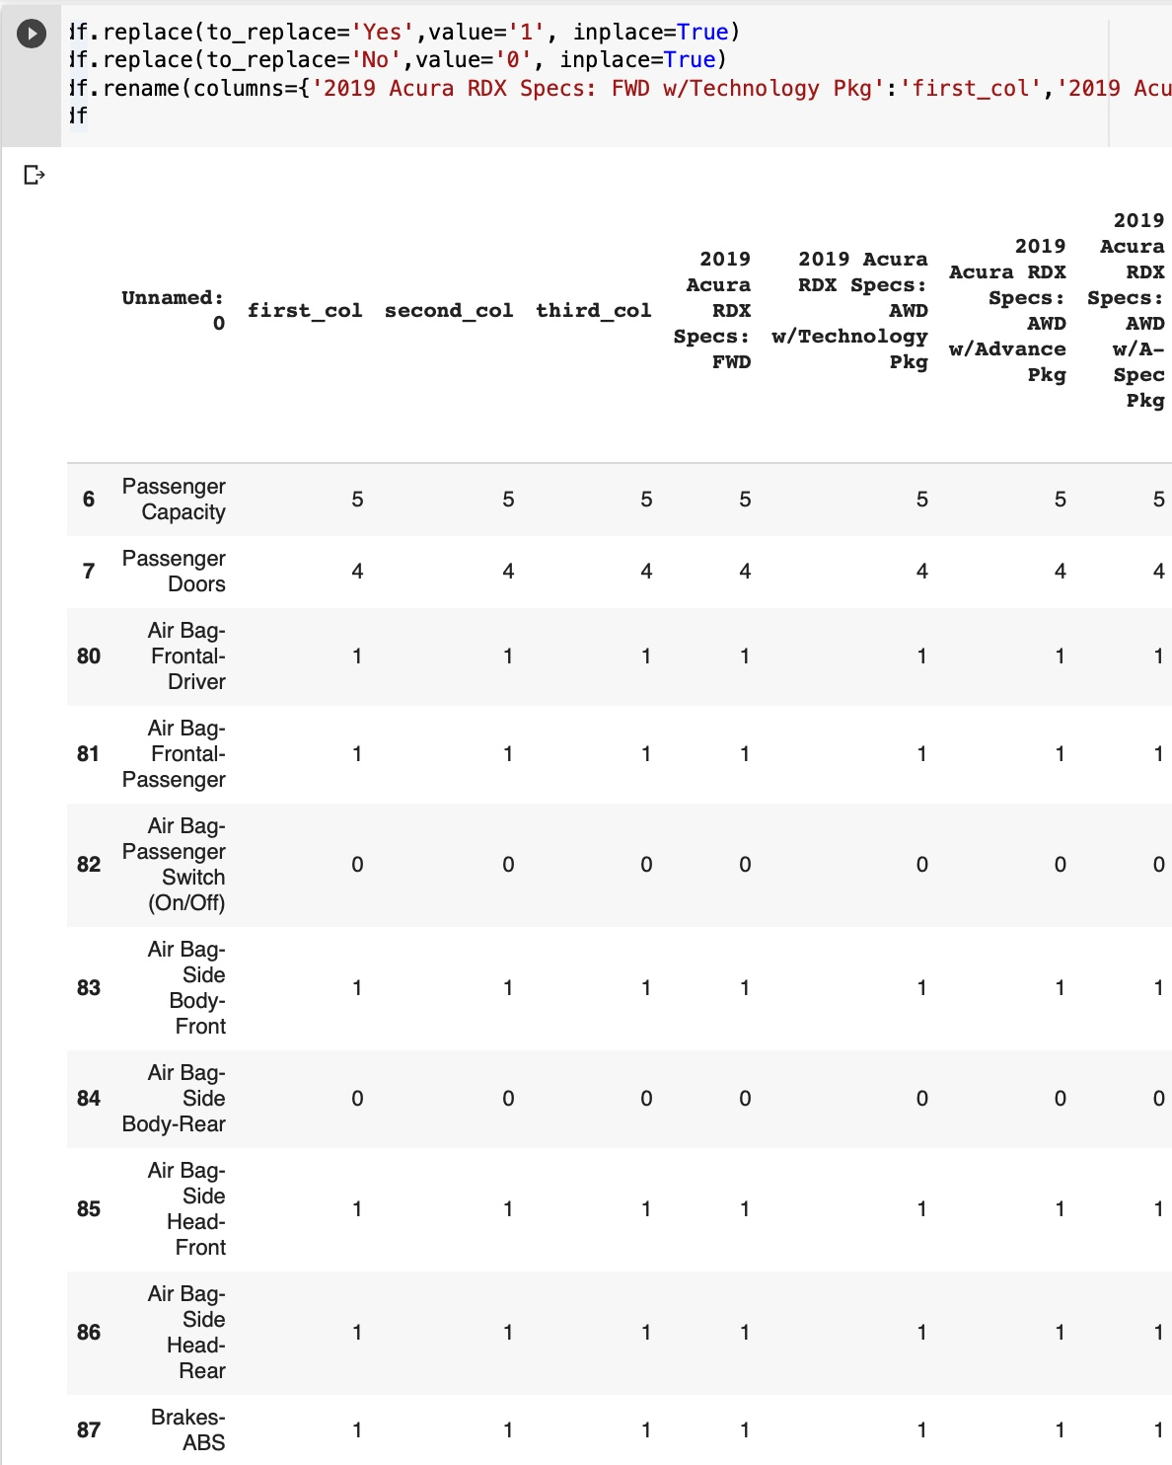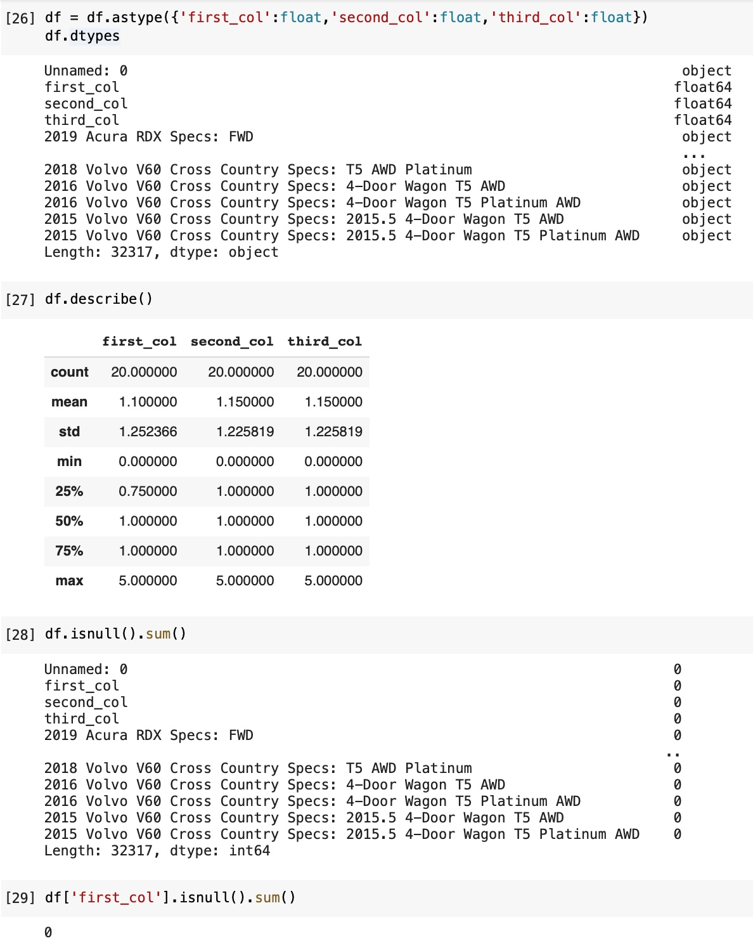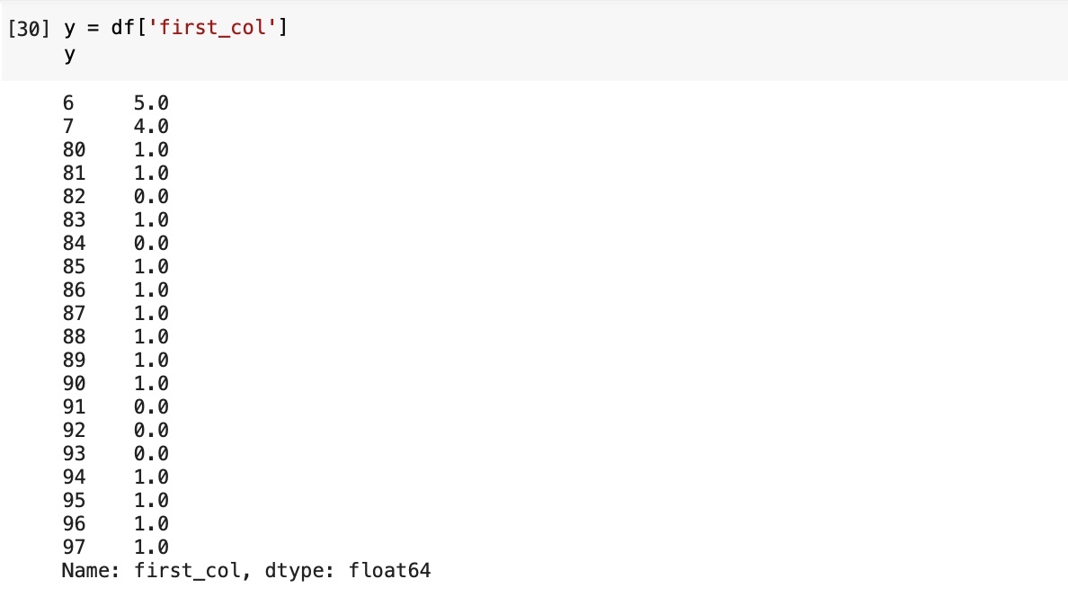 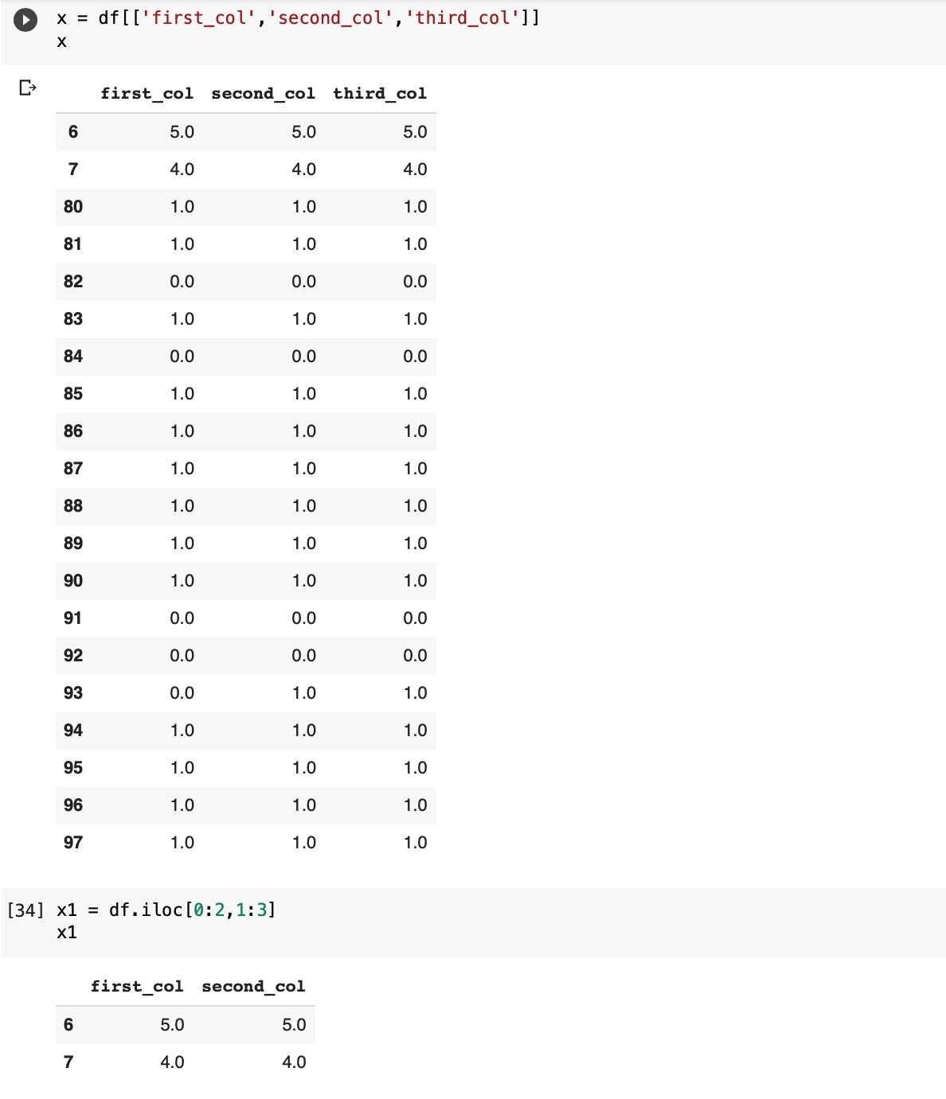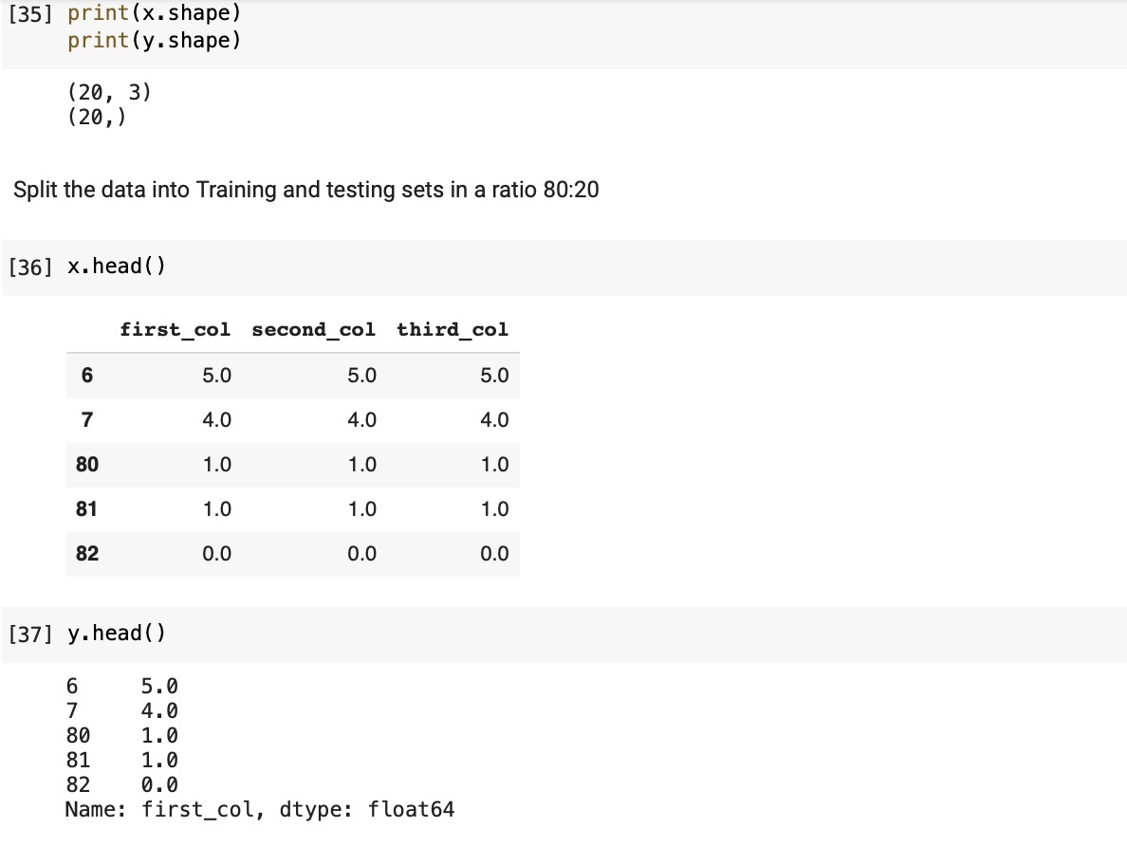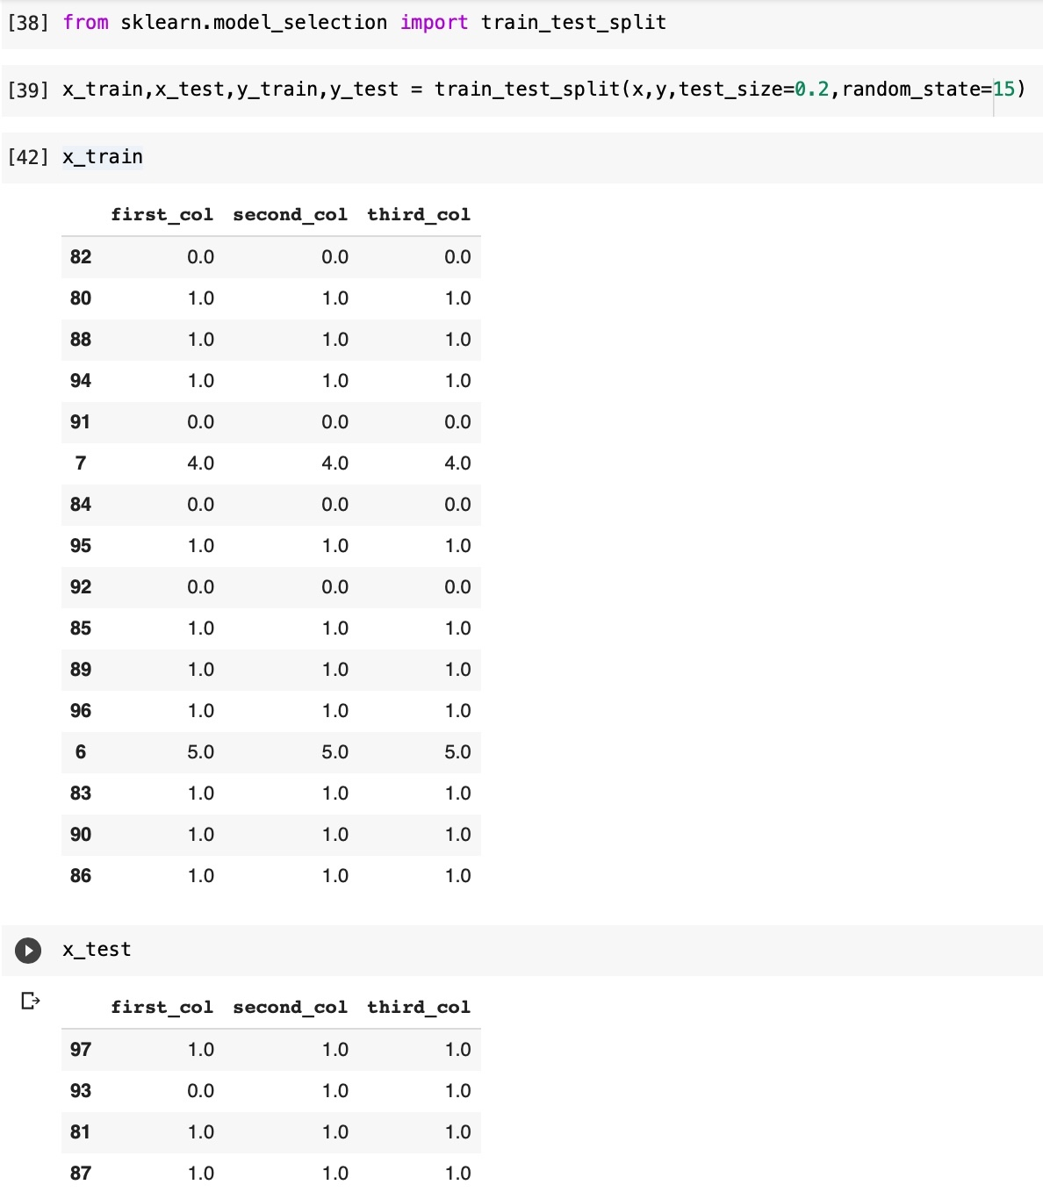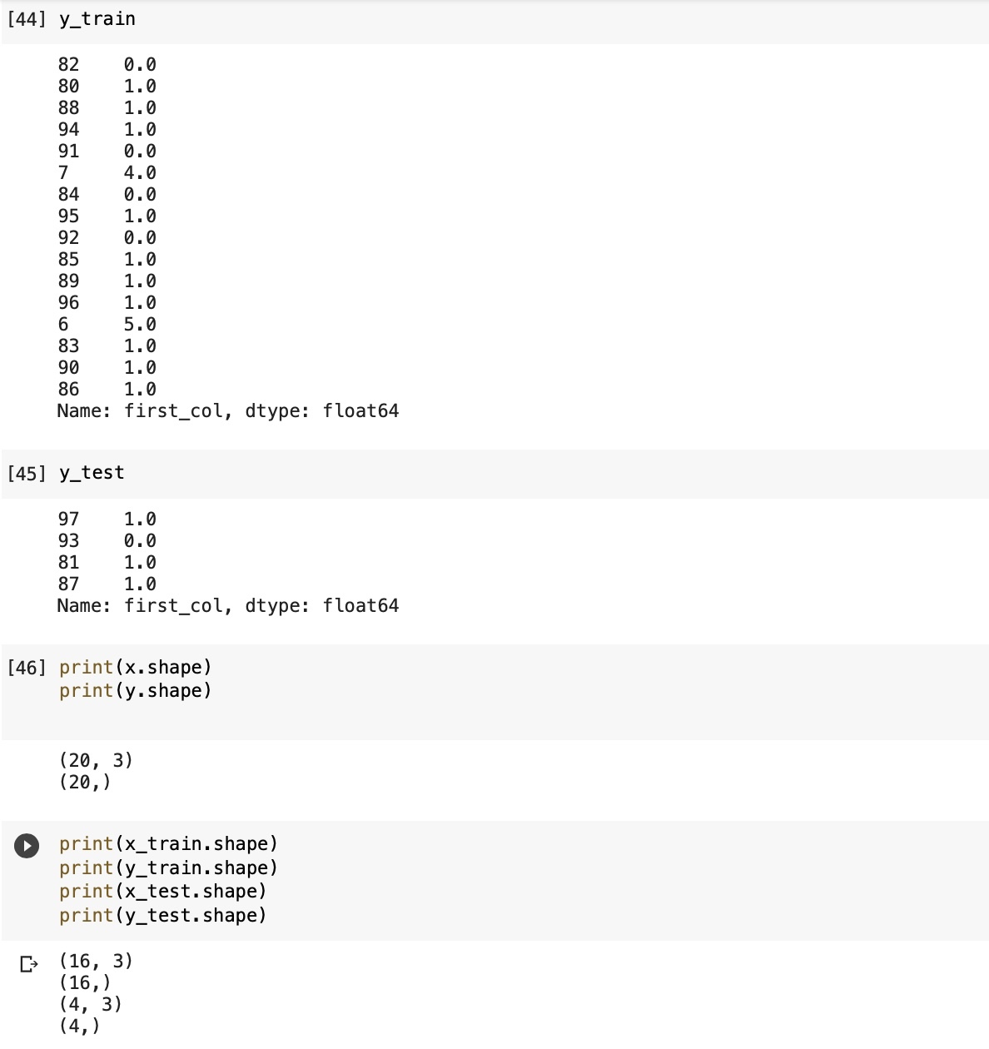 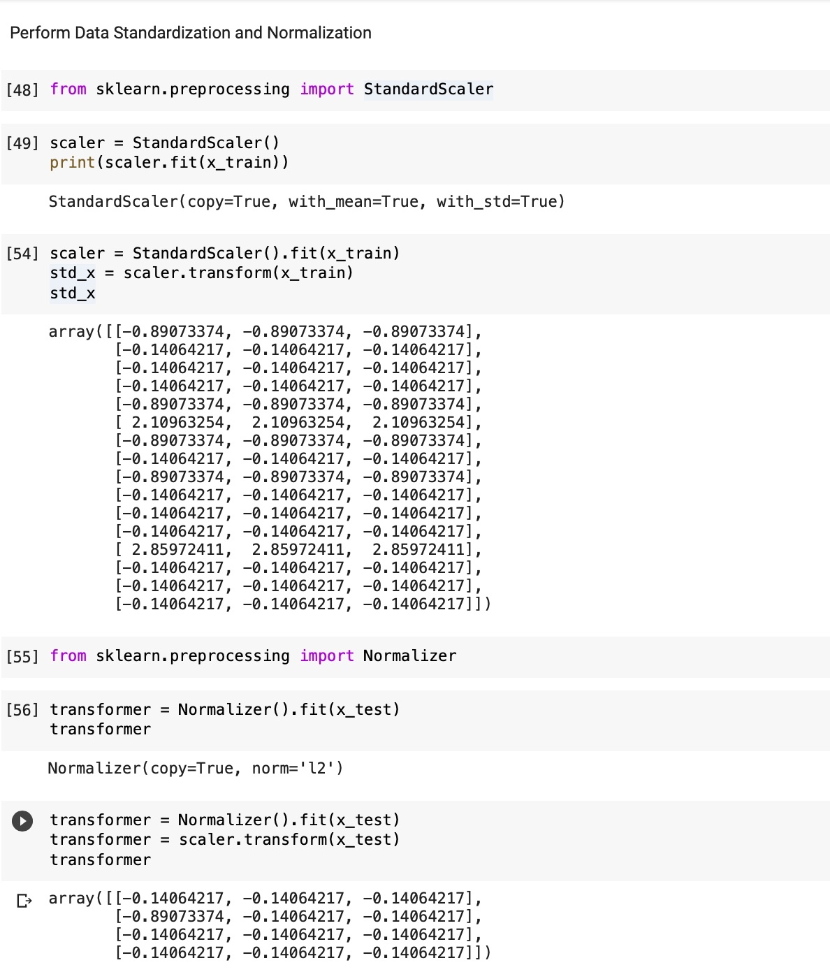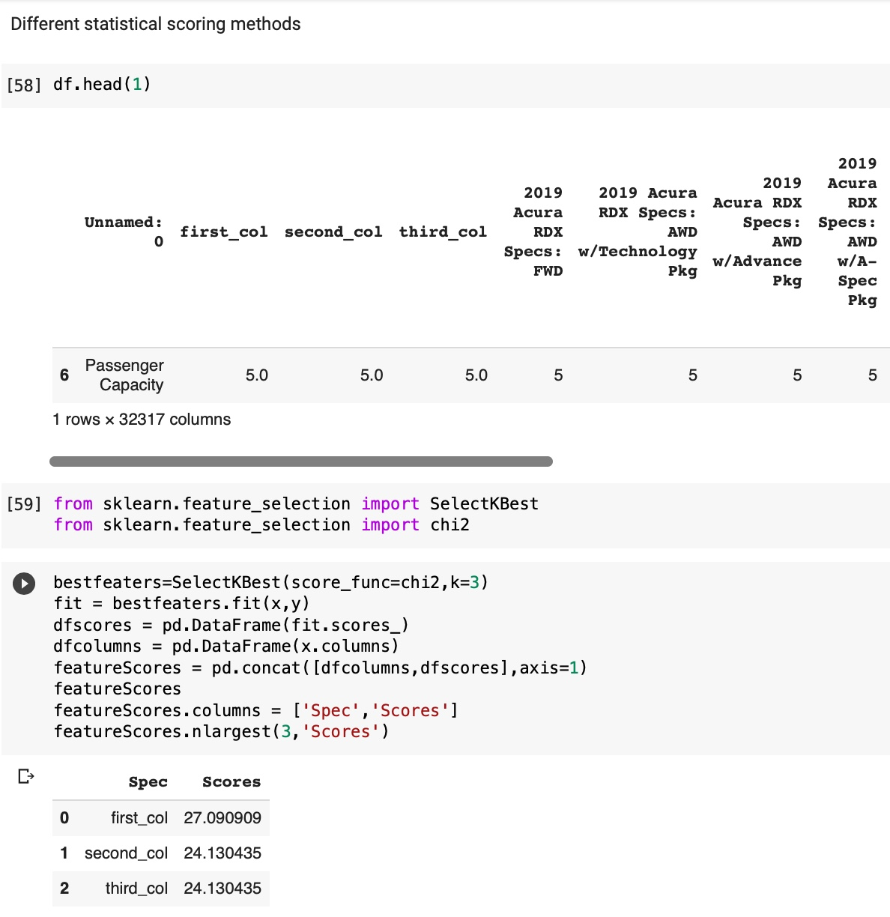

**PRACTICAL 3**



TASK DESCRIPTION:

Implement the linear regression and calculate the different evaluation measure (MAE, RMSE etc.). for the same. Also implement gradient descent and observe the cost with linear regression using gradient descent. Do not use any Python library for linear regression.

(Hint: Linear Regression Formula is Y= mX +b where Y is target variable and X is independent variable)

# Data Used for Problem

## Dataset Description:

Dataset is downloaded from Kaggle.

Dataset name is Fifa19 Dataset.

Dataset has 32317 number of attributes and 234 number of samples.

Dataset has 2 types of samples. (Numerical And Categorical)

Does dataset have a target attribute? [NO]

## Did it have missing values and how did you deal with them?

Yes dataset consist of missing values, used a dropna function to deal with it.

## Did you perform any data transformation tasks?

Yes.

## Did you perform any other data wrangling tasks?

No.

# Machine Learning Model

## What algorithm/ model did you use and with which parameters?

Linear Regression.

## What are other algorithms/ models you could have used alternatively?

NaN.

## What percentage of the dataset did you use for training and testing and how long did you train for in terms of iterations/convergence/epochs?

80:20.

# Evaluation

## Which evaluation metric(s) did you use for the task?

RMSE for error calculation.

## Did your model underfit or overfit or did it perfectly fit the test data?

Perfectly Fit.

## Did you train and evaluate the model again after changing its parameters? Why?

Yes, I tried to increase the number of epochs.

## What was the final accuracy/evaluation metric score that you obtained?

NaN.

PRACTICAL LEARNING OUTCOME:

From this practical we learned how to use linear regression and gradient descent.

CODE & OUTPUT:

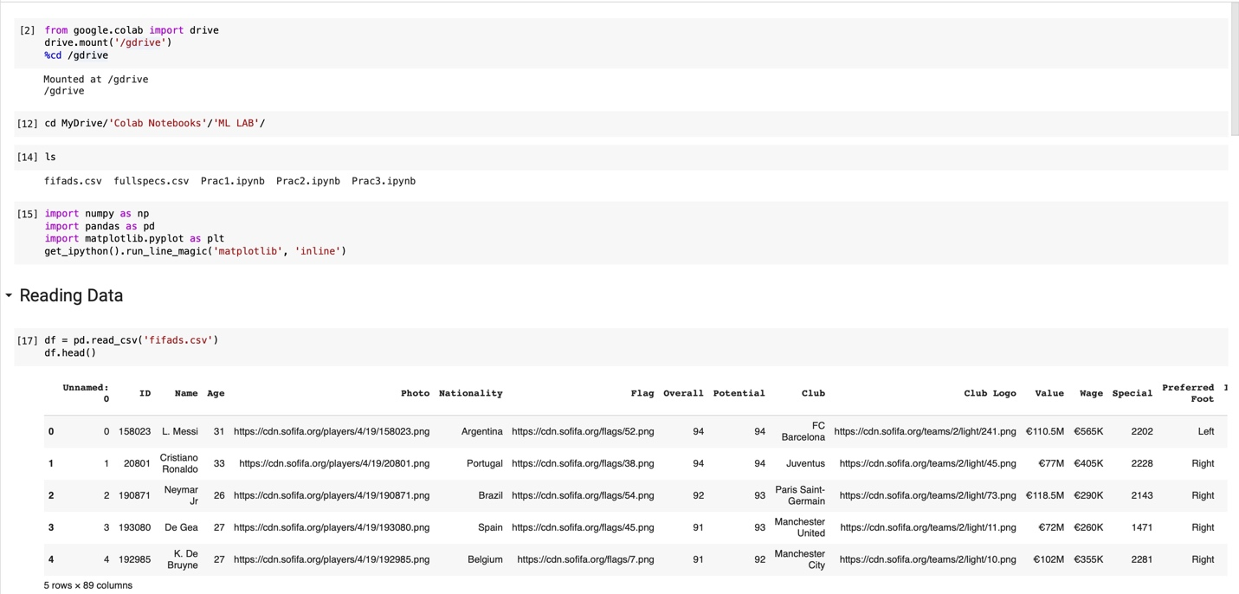

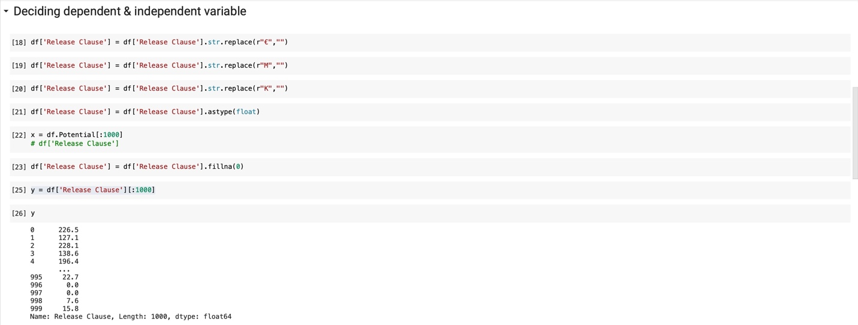 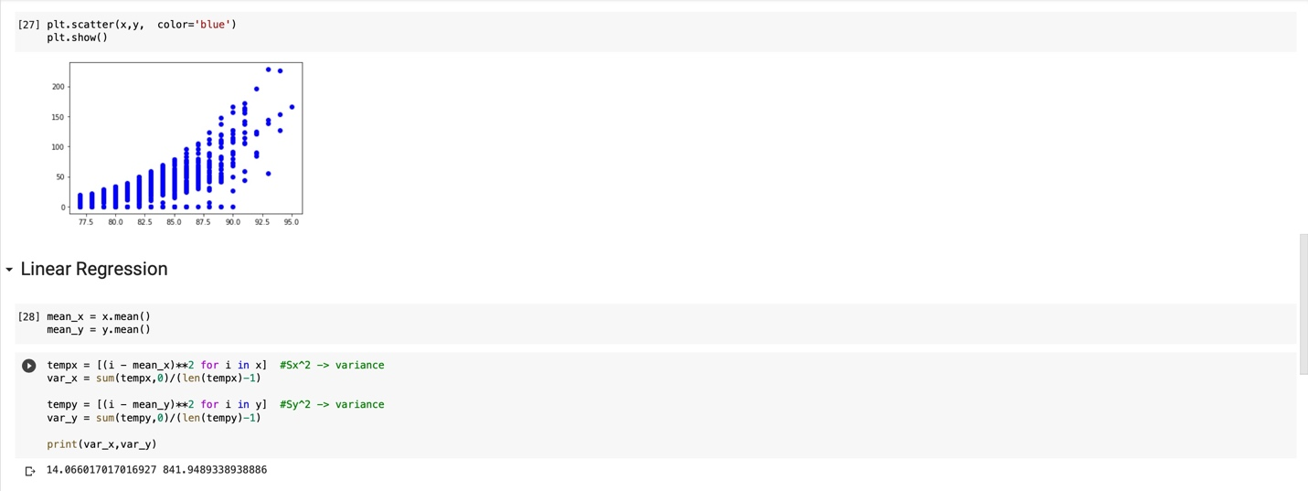

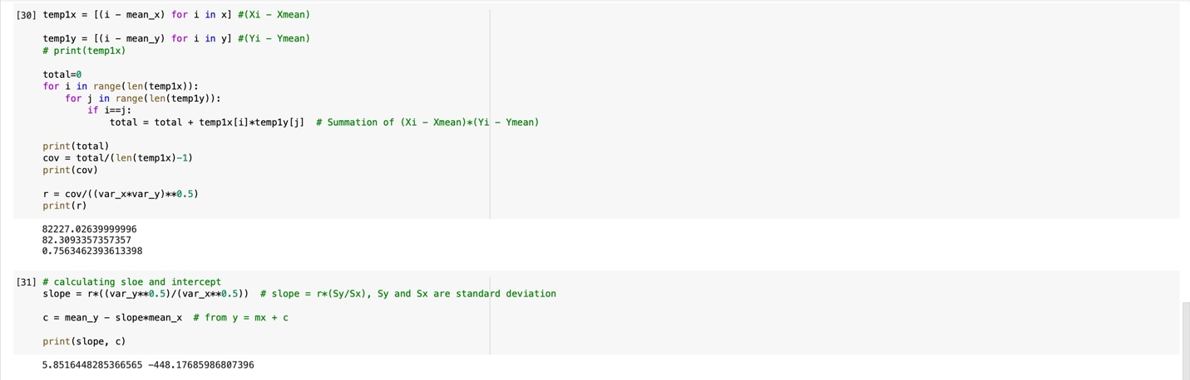

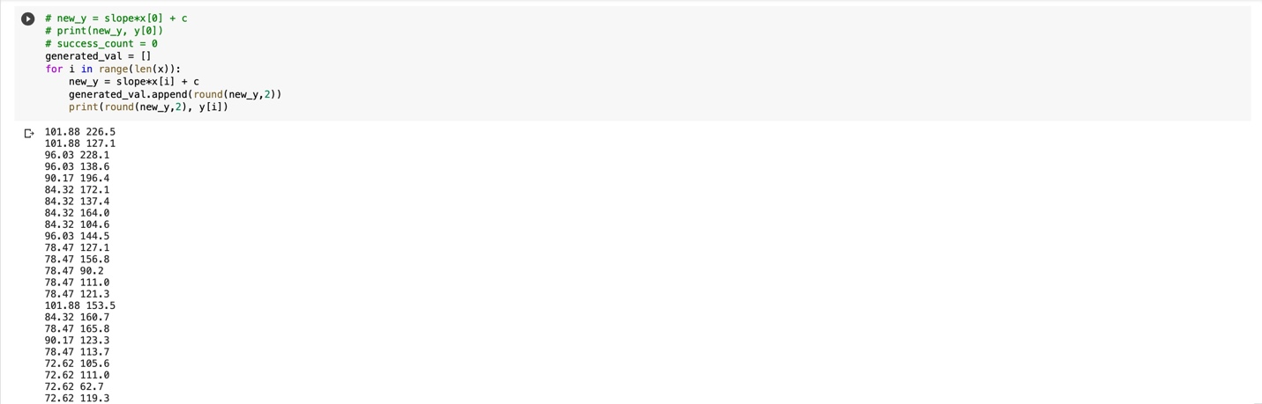

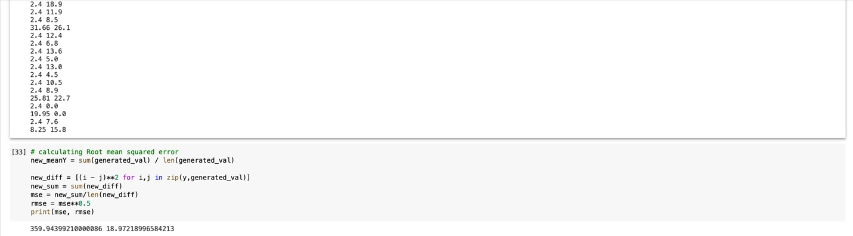

**PRACTICAL 4.1**



TASK DESCRIPTION:

Implement Multi-class Classification using Orange Data Mining Tool by making use of widgets. Visualize and Analyze the results. Datasets to be used are available in Orange itself.

# Data Used for Problem

## Dataset Description:

Dataset is downloaded from https://drive.google.com/file/d/1HnpfG2xj_6EZ7Tgle2QB9Yn_YS7r7uV

Dataset name is Car Evalution

Dataset has 6 number of attributes and 1728 number of samples.

Dataset has 1 types of samples. (Numerical)

Does dataset have a target attribute? [YES]

## Did it have missing values and how did you deal with them?

NaN.

## Did you perform any data transformation tasks?

NaN.

## Did you perform any other data wrangling tasks?

NaN.

# Machine Learning Model

## What algorithm/ model did you use and with which parameters?

K-NN

## What are other algorithms/ models you could have used alternatively?

NaN

## What percentage of the dataset did you use for training and testing and how long did you train for in terms of iterations/convergence/epochs?

80:20

# Evaluation

## Which evaluation metric(s) did you use for the task?

Confusion Matrix, Average score, Precision, F1 score.

## Did your model underfit or overfit or did it perfectly fit the test data?

Perfectly fit.

## Did you train and evaluate the model again after changing its parameters? Why?

NaN

## What was the final accuracy/evaluation metric score that you obtained?

87.9

PRACTICAL LEARNING OUTCOME:

From this practical we learned how to use the orange tool for visualization and analysis of data.

OUTPUT:









**PRACTICAL 4.2**



TASK DESCRIPTION:

Demonstrate the basic usage of Weka Data mining Tool.

# Data Used for Problem

## Dataset Description:

Dataset is downloaded from Weka

Dataset name is Breast Cancer Data.

Dataset has 10 number of attributes and 286 number of samples.

Dataset has 1 types of samples. (Categorical)

Does dataset have a target attribute? [YES]

## Did it have missing values and how did you deal with them?

NaN.

## Did you perform any data transformation tasks?

NaN.

## Did you perform any other data wrangling tasks?

NaN.

# Machine Learning Model

## What algorithm/ model did you use and with which parameters?

J-48

## What are other algorithms/ models you could have used alternatively?

Logistic regression, Random forest, lazy-IBK.

## What percentage of the dataset did you use for training and testing and how long did you train for in terms of iterations/convergence/epochs?

50 cross validations.

# Evaluation

## Which evaluation metric(s) did you use for the task?

Confusion Matrix, Average score, Precision, F1 score.

## Did your model underfit or overfit or did it perfectly fit the test data?

Perfectly fit.

## Did you train and evaluate the model again after changing its parameters? Why?

NaN

## What was the final accuracy/evaluation metric score that you obtained?

75.8716%

PRACTICAL LEARNING OUTCOME:

From this practical we learned how to use the weka tool for visualization and analysis of data.

OUTPUT:

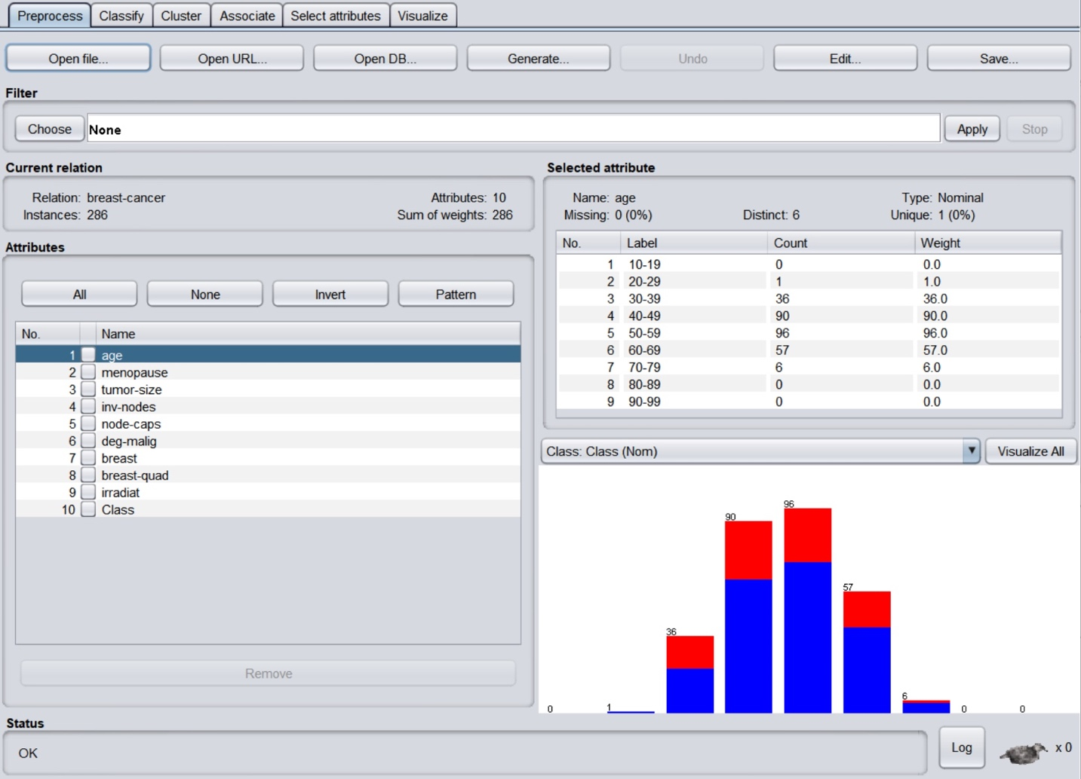

Preprocess of Data

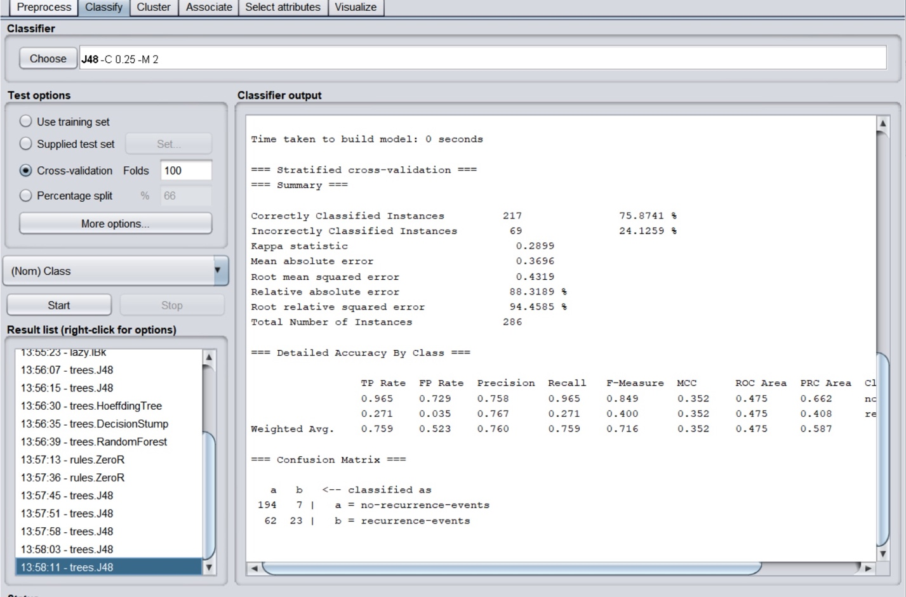

Classifier Output

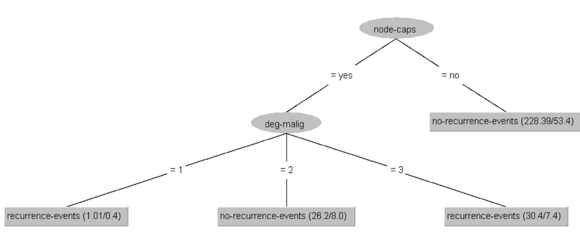

Visual Tree

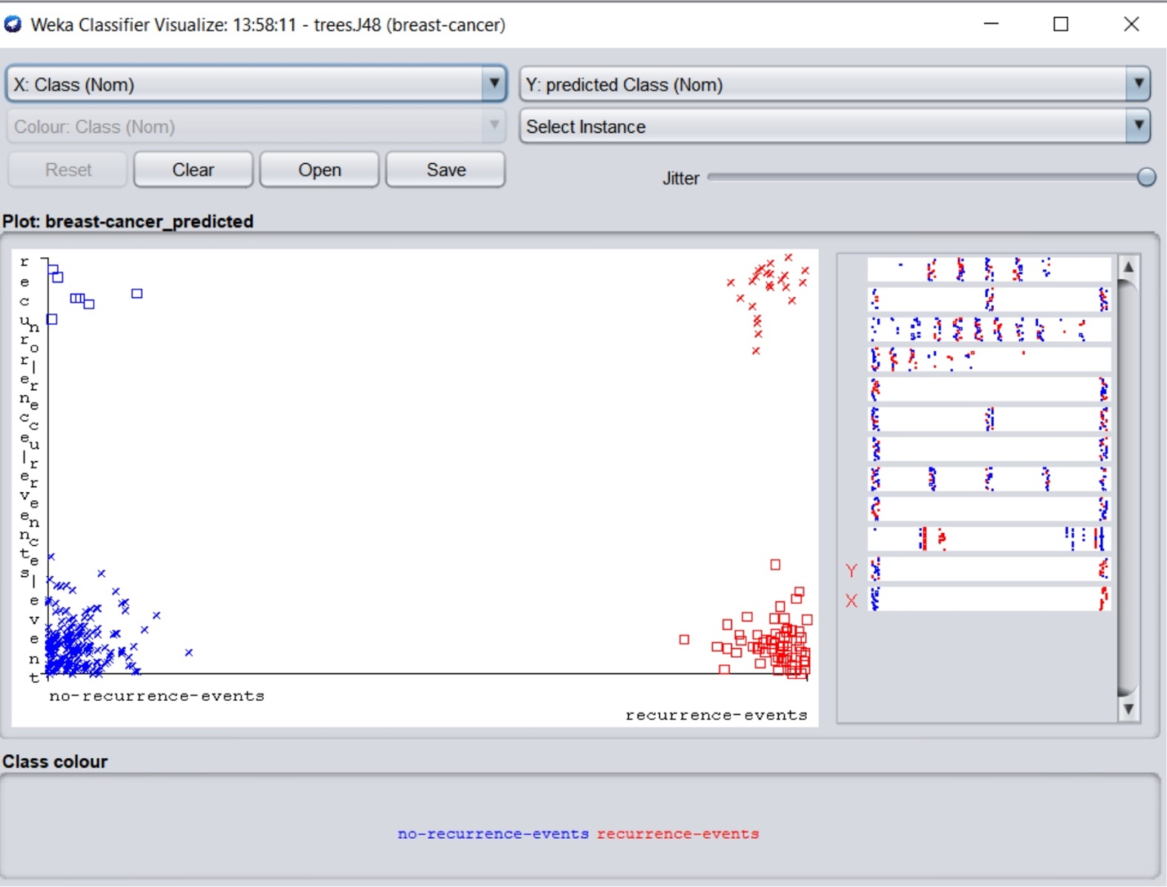

Classifier Visual Plot

**PRACTICAL 5**



TASK DESCRIPTION:

Implement logistic regression and calculate the different evaluation measure (F-measures, Confusion Matrix etc.) for the same. Also implement gradient descent and observe the cost with logistic regression using gradient descent.

(Hint: Confusion Matrix and F-measures involve use of True Negatives, True Positives, False Negatives and False Positives). Also implement Cross- Validation.

# Data Used for Problem

## Dataset Description:

Dataset is downloaded from Kaggle.

Dataset name is Graduate Admission 2.

Dataset has 9 number of attributes and 400 number of samples.

Dataset has 1 types of samples. (Numerical)

Does dataset have a target attribute? [YES]

## Did it have missing values and how did you deal with them?

NaN.

## Did you perform any data transformation tasks?

NaN.

## Did you perform any other data wrangling tasks?

NaN.

# Machine Learning Model

## What algorithm/ model did you use and with which parameters?

Logistic Regression.

## What are other algorithms/ models you could have used alternatively?

K-NN, Random Forest.

## What percentage of the dataset did you use for training and testing and how long did you train for in terms of iterations/convergence/epochs?

8:2

# Evaluation

## Which evaluation metric(s) did you use for the task?

Confusion matrix, K-fold.

## Did your model underfit or overfit or did it perfectly fit the test data?

Perfectly Fit.

## Did you train and evaluate the model again after changing its parameters? Why?

NaN.

## What was the final accuracy/evaluation metric score that you obtained?

77 %

PRACTICAL LEARNING OUTCOME:

From this practical we learned how to use logistic regression and how to use cross validation.

CODE & OUTPUT:

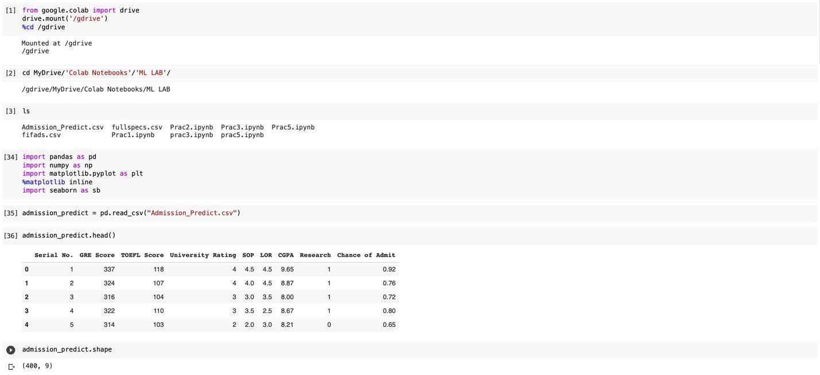

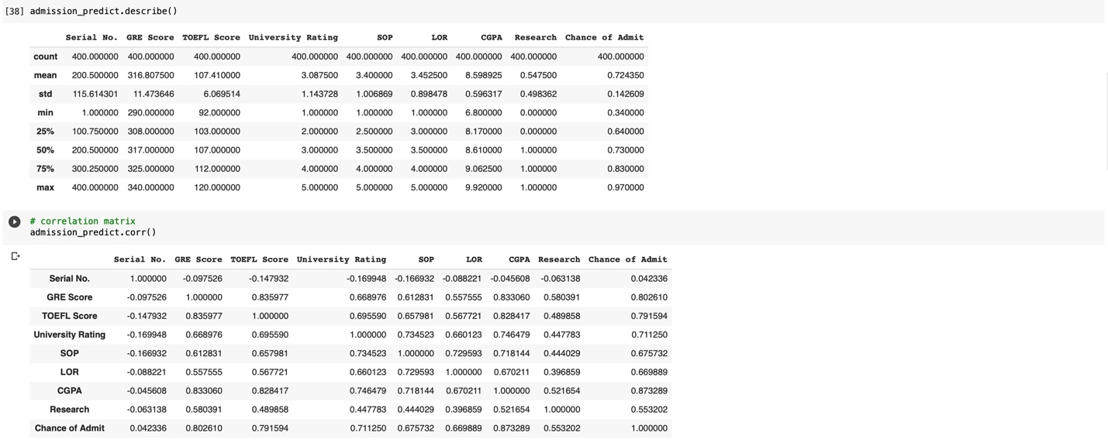

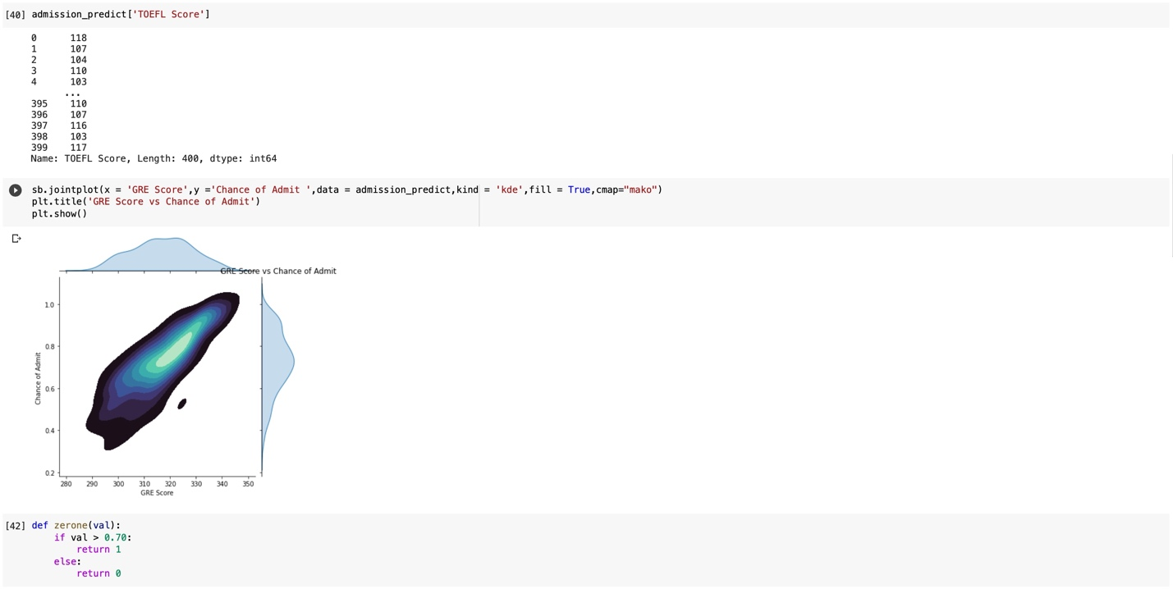

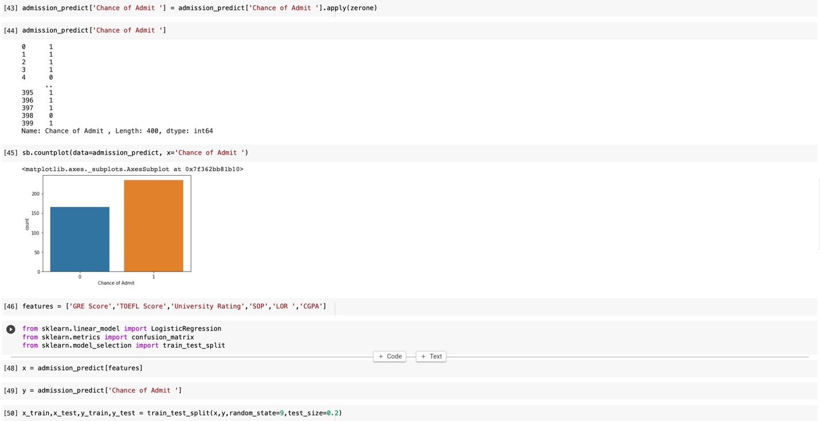

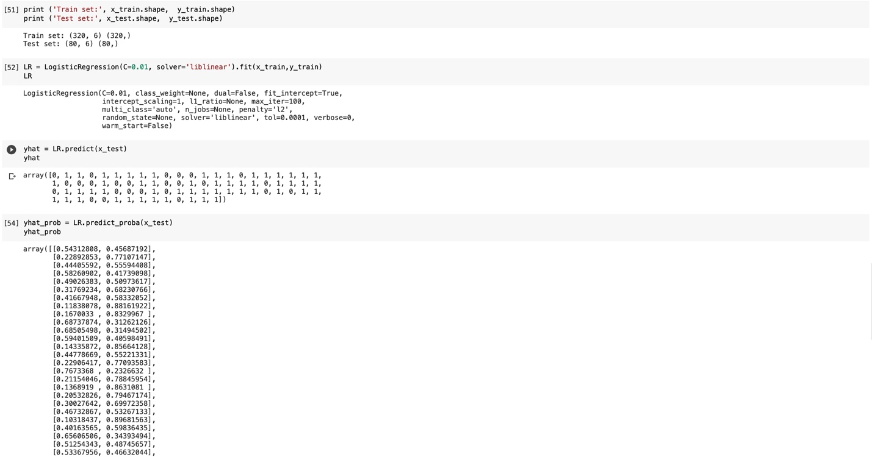

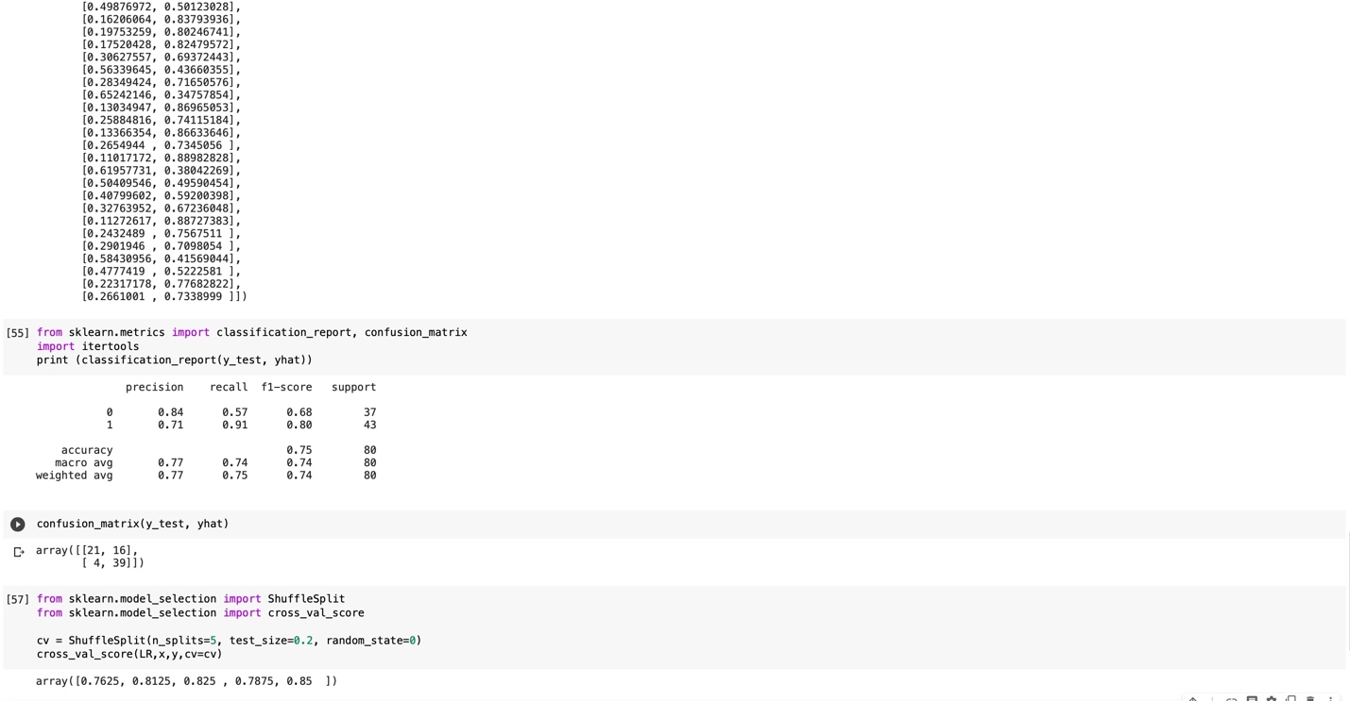

**PRACTICAL 6**



TASK DESCRIPTION:

Implement K-Nearest Neighbours, Support Vector Machine (SVM) and Naïve Bayes Classifier with python’s Scikit-Learn on different datasets. Compare the classifiers based on their evaluation measures.

# Data Used for Problem

## Dataset Description:

Dataset is downloaded from <https://archive.ics.uci.edu/ml/datasets/Covertype>

Dataset name is Covertype Data Set

Dataset has 581011 number of attributes and 55 number of samples.

Dataset has Numerical and Categorical types of samples.

Does dataset have a target attribute? NO

## Did it have missing values and how did you deal with them?

No Missing Values

## Did you perform any data transformation tasks?

No

## Did you perform any other data wrangling tasks?

No

# Machine Learning Model

## What algorithm/ model did you use and with which parameters?

K nearest neighbors, Naïve bayes, Support Vector Machine

## What are other algorithms/ models you could have used alternatively?

Neural network, Decision tree

## What percentage of the dataset did you use for training and testing and how long did you train for in terms of iterations/convergence/epochs?

100% data was used for training.

# Evaluation

## Which evaluation metric(s) did you use for the task?

Classification report

## Did your model underfit or overfit or did it perfectly fit the test data?

Perfect

## Did you train and evaluate the model again after changing its parameters? Why?

No

## What was the final accuracy/evaluation metric score that you obtained?

Same as before

PRACTICAL LEARNING OUTCOME:

In this practical we learned about different classification algorithms like Support vector machine, naïve bayes and k nearest neighbors.

OUTPUT & CODE:

import pandas as pd

from sklearn.neighbors import KNeighborsClassifier

from sklearn.svm import LinearSVC

from sklearn.naive_bayes import GaussianNB

from sklearn.metrics import classification_report

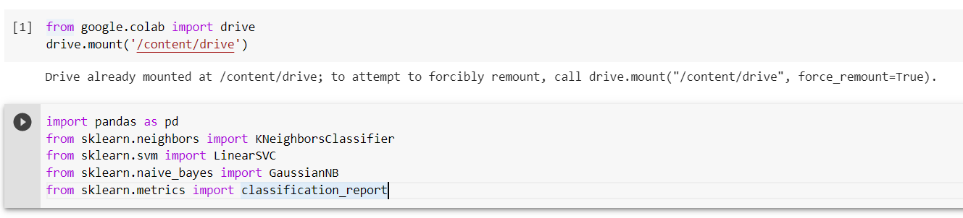

df = pd.read_csv("/content/drive/MyDrive/ML_practicals/Practical_6/covtype.data")

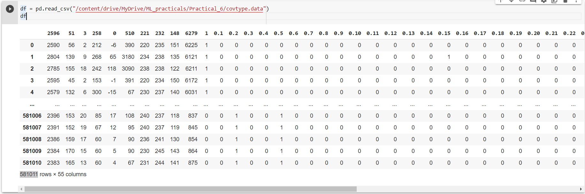

Df.describe()

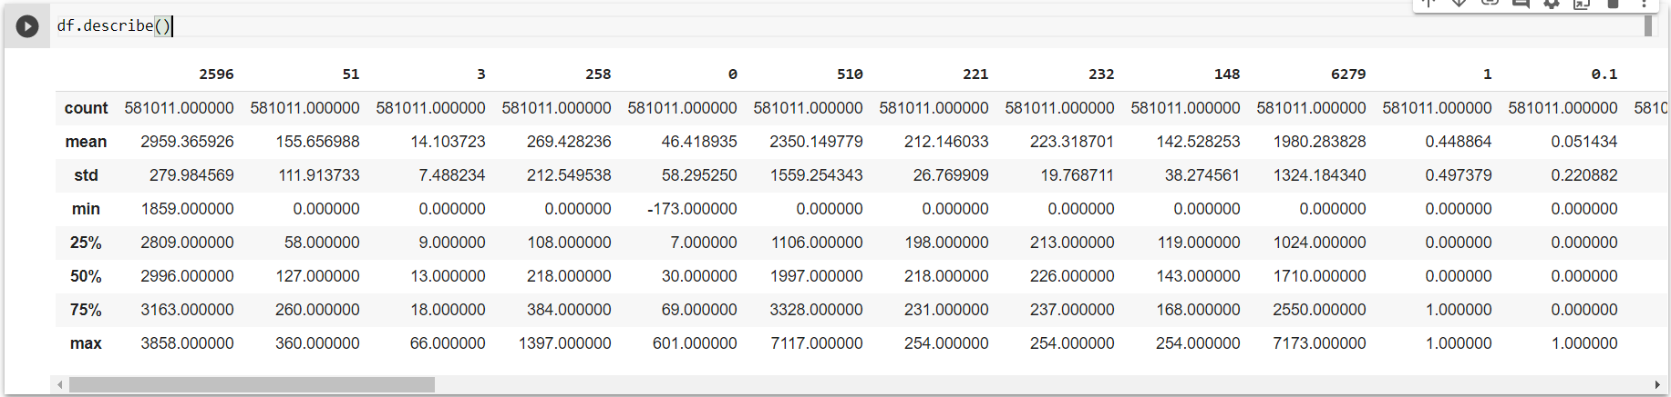

Df.isna().sum()

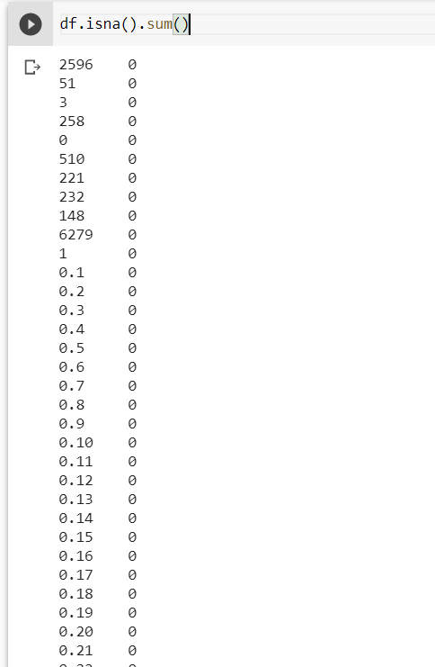

Y = df["1"].copy()

X = df[["51","510","221"]]

print(X.shape)

print(Y.shape)

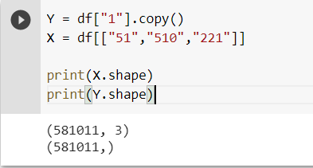

neigh = KNeighborsClassifier(n_neighbors=5)

neigh.fit(X,Y)

y_knn = neigh.predict(X)

print(y.knnshape)

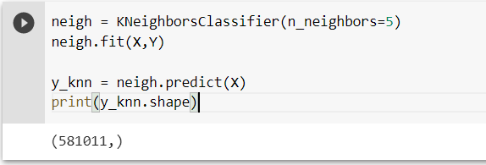

nb_class = GaussianNB()

nb_class.fit(X,Y)

y_nb = nb_class.predict(X)

print(y_nb.shape)

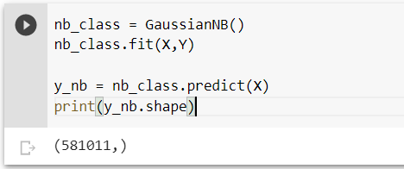

svm_class = LinearSVC()

svm_class.fit(X,Y)

y_svm = svm_class.predict(X)

print(y_svm.shape)

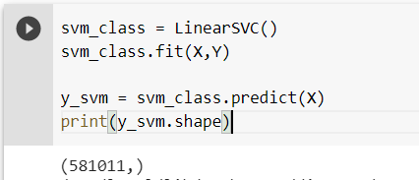

print(classification_report(y_knn, Y))

print(classification_report(y_nb, Y))

print(classification_report(y_svm, Y))

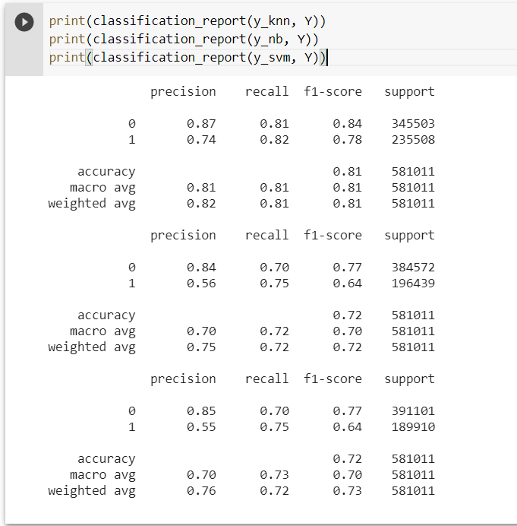

**PRACTICAL 7**



TASK DESCRIPTION:

Use K-Means Clustering and Hierarchical Clustering algorithm for following datasets.

# Data Used for Problem

## Dataset Description:

Dataset is downloaded from <https://www.kaggle.com/c/santander-customer-satisfaction/data>

Dataset name is Santander Customer Satisfaction

Dataset has 76020 number of attributes and 371 number of samples.

Dataset has Numerical types of samples.

Does dataset have a target attribute? YES

## Did it have missing values and how did you deal with them?

No

## Did you perform any data transformation tasks?

No

## Did you perform any other data wrangling tasks?

We took only 5000 rows and 50 columns to reduce computation.

# Machine Learning Model

## What algorithm/ model did you use and with which parameters?

K-Means clustering and hierarchical clustering

## What are other algorithms/ models you could have used alternatively?

Mean shift clustering, DBSCAN

## What percentage of the dataset did you use for training and testing and how long did you train for in terms of iterations/convergence/epochs?

100% of data was used for training.

# Evaluation

We just plotted the graph.

## Did your model underfit or overfit or did it perfectly fit the test data?

Perfect

## Did you train and evaluate the model again after changing its parameters? Why?

No

## What was the final accuracy/evaluation metric score that you obtained?

Same as before

PRACTICAL LEARNING OUTCOME:

From this practical we learned how to use logistic regression and how to use cross validation.

In this practical, we learned about unsupervised learning and clustering algorithms like Kmeans and Hierarchical clustering. We implemented both the algorithms using sklearn.

OUTPUT & CODE:

import numpy as np

import pandas as pd

from sklearn.cluster import KMeans

from sklearn.cluster import AgglomerativeClustering

import matplotlib.pyplot as plt

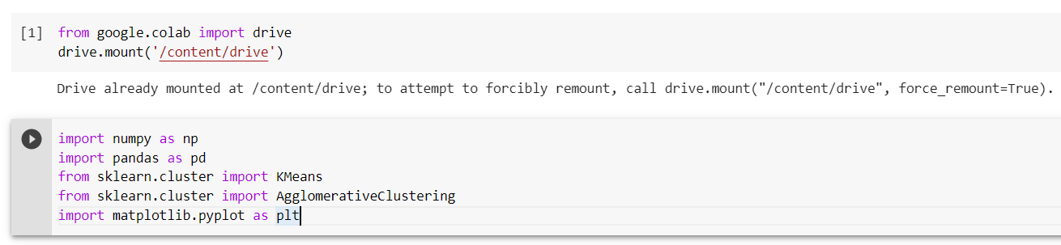

df = pd.read_csv("/content/drive/MyDrive/ML_practicals/Practical_7/train.csv")

df

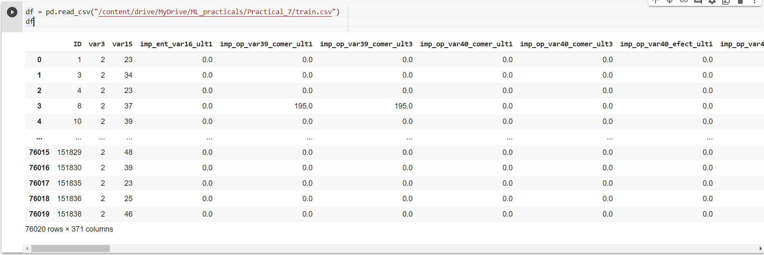

df = df.iloc[:5000, :50]

df = df.iloc[:5000, :50]

df.describe()

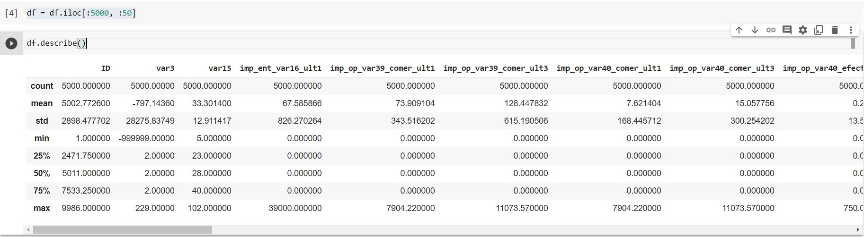

k_means_score = []

for i in range(1,11):

kmeans = KMeans(n_clusters=i)

kmeans.fit(df)

k_means_score.append(kmeans.inertia_)

plt.plot(range(1,11), k_means_score)

plt.show()

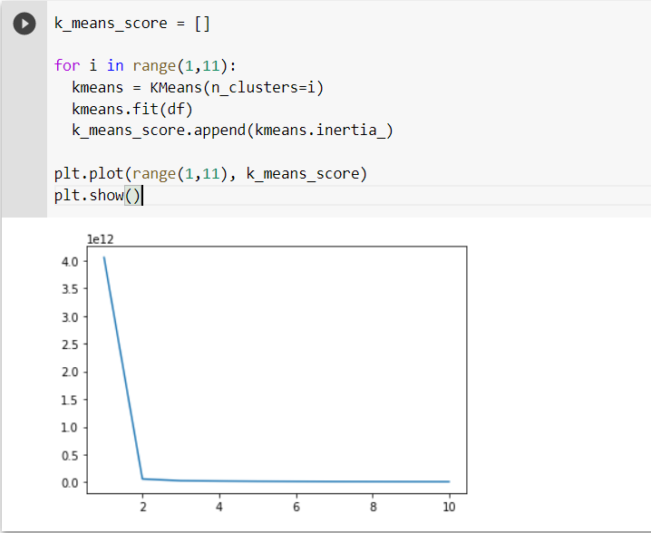

kmeans = KMeans(n_clusters=2)

y_kmeans = kmeans.fit_predict(df)

df = np.array(df)

plt.scatter(df[y_kmeans==0, 0], df[y_kmeans==0, 1], c="red")

plt.scatter(df[y_kmeans==1, 0], df[y_kmeans==1, 1], c="blue")

plt.scatter(kmeans.cluster_centers_[:,0], kmeans.cluster_centers_[:,1],c="yellow")

plt.show()

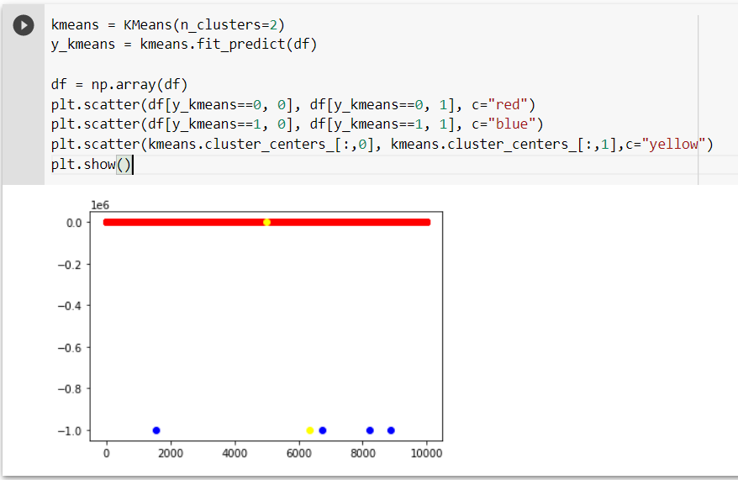

cluster = AgglomerativeClustering(n_clusters=2)

cluster.fit_predict(df)

plt.scatter(df[:,0], df[:,1], c=cluster.labels_, cmap="rainbow")

plt.show()

